The AZ of Benidorm
The essential guide for visiting Benidorm Street maps and bus stops with route information. Helpful guides to navigate your way around Benidorm If you arrive with a tour then you may avoid the coach from Alicanti airport. The coach is hourly from 7 am to 7pm then 2 more coaches at 9pm and 11 pm. You pay for a ticket at the machine with cash or card a fee of 8 Euros. The coach take 40 Minutes to the centre of Benidorm on the Avenue de Europa
If you use a card make sure it works on all currency otherwise you will be charged a conversion fee. We suggest you have a Chase card. In the UK you would download Chase UK on your phone With a Passport and selfie you can get the account in 5 minutes with the card being delivered in three days.
If you want more Euros you can go this shop near the Casino on the “EuroTabac” Avenue Mediterraneo No 58. They have another shop on Avenue Juan Fuster Zaragoza. Another is in a Samsung & Apple Phone shop owner Guru Ji Leo at Mediterraneo No 19. There are many other exchanges to obtain Euros but they only take cash. If you find one that takes cards please let us know so we can add it to our website and the next edition.
The main entertainment is on the Calle Genora found near the Airport Bus Stop on Avenue de Europa this starts at the Bulldog Pub on the corner of Avenue Mediterraaneo. Walk down Genoa and it has many shows, pubs until at the end you will find the Palladium with the famous Sticky Vicki, now a Carmen Black has taken her job and the great comedy act of Gary George before hand. San Miguel is 3.60 Euros here but no entrance fee. Very few places have entrance fees in Benidorm.
You can go further for the famous Piccadilly Karaoke where they have a comic compare Taz from 8 pm until 2.30 hrs in the morning. Karaoke starts at 3 pm with Tim or Clare until 8pm when Taz takes over so don’t go if you are easily offended .This has the reputation of being the best bar in Benidorm with an Amstel Beer for 2 Euros.
There are many good bars on the entertainment street The Railway and The Rose and Crown insult the UK with the Union Jack Upside down Ckarlies Bar is good as it flies it the correct way. Most of the bars say they are English. Many sorts bars show horse racing and there is a bookies nearby if you want to put your Euros on a horse or a football game.
CRIME
You really must have travel insurance for travel to Benidorm as there is a crime epidemic. Favourites are gold chains, watches, wallets, handbags and especially mobile phones stolen at least a 100 a day.
If you have important photos in your wallet make copies and leave them at home. Make a note of your phones IMEI numbers and do not rely on your sim provider as one did the thief just used the empty sim slot as she had two sim slots. You should always back up your phone in case it is stolen. There is a four port phone backup available from Webhouses.co.uk. The same company has flat rentals for Benidorm from weekly to longer term. If you want to buy a property in Benidorm they also have offerings with estate agents in Benidorm itself.
If you are a victim of a crime the police will refer you to the Tourist Police. This is a white house near the Palladium at the end of Calle Genoa the entertainment streer and opposite the Flash Hotel. The police will take your crime down and give you a crime number for your insurane. Don’t expect anything more from them unless you visit the Mayor and complain. One person had all his belongings stolen and only had the clothes he came in at the Welcome Hotel in the Old Town by the owner has he wanted to extort more money for his accommodation.
Transport Hire
In Benidorm you can hire and you will see these everywhere all for rental. Between the Flash Hotel and the Tourist Police station and the Piccadilly Karaoki bar is My Rental.
Deposit of 20 Euros daily rates cheaper rates for longer hire
Simple scooter 1 person 20 Euros
Double scooter 2 persons 30 Euros
E-Bike 15 Euros
Scooter 12 Euros Motor Bike 125cc 25 Euros
Water Bike 300 Euros
Monkey Rent has the same offers and covers other towns as well in Bendidorm at Calle Valecncia 1
Tel +34 673 356 274 or +34 966 156 045 They can deliver to your hotel.
All come with chargers and you need to check with your hotel if they allow you to charge there. Lost your Passport
Go to the Tourist Police and report it. On the wall is a UK poster explaining how to get a temporary travel document for 125 Euros so you can return to the UK. See the form here. You have to pick it up in Alicanti.
Benidorm to Alicanti by Train
There is a train from the station in Benidorm and a ticket costs 2.40 Euros trains every hour. The train someimes has black spotty windows, so you have a hard time getting photos of the scenery. It takes one and a half hours and have plastic seats so take a cushion if you can.
Bus Number 1 indicating Estacion the Avenue de Mediterraneo (direction old town where the white sky rings are)
If you think this is a good way to the airport it isn’t as th coach for a 10 minute journey costs 4.80 Euros. Better get the coach from Avenue de Europa near the Bulldog bar on Avenue de Mediterraneo hourly from 6 am until 9 pm it costs 8 Euros . It takes 45 minutes. It is best get a ticket at the office open from 8 am until 8 pm closed for lunch 12 util 2 pm. The driver can take cash, or cards but you have to wait to be last if you don’t have a ticket grumble grumble.
Rental Flats weekly, or purchasing a Benidorm Property
Flats can be rented on webhouses.co.uk see Benidorrm Rentals in the sales. See the Properties available for sale from the Benidorm agents there.
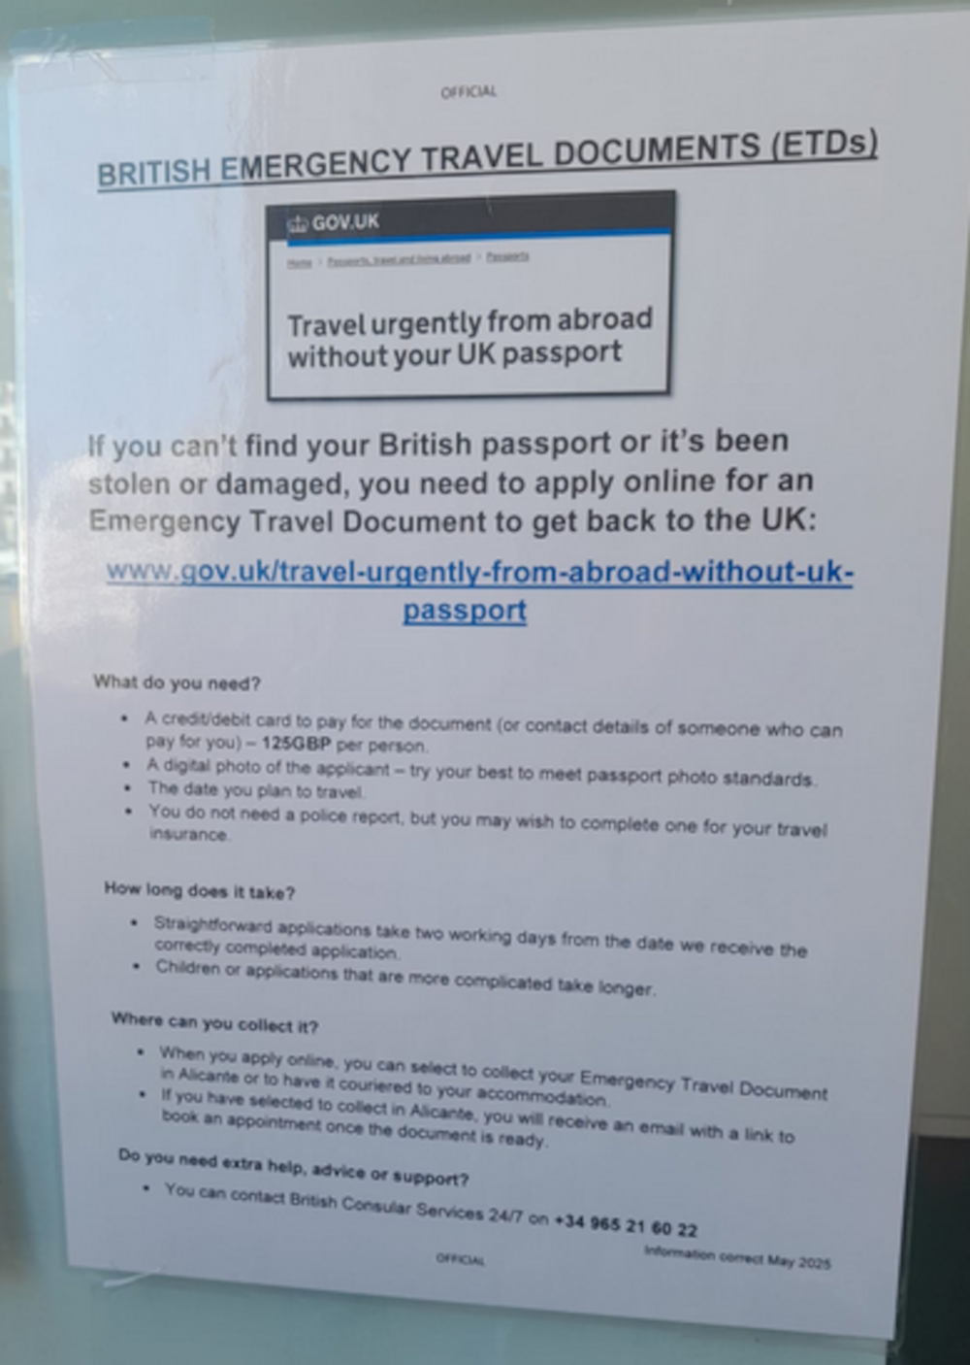
Eating Out
There are many places to eat in Benidorm so we recommend just a few tried and tested.
There is a 24 hour Restaurant that is very good next door to the Piccadilly Karaoke Bar. It has an enormous range so see the menus later with good prices. Breakfast for 4.95 Euros. Tea 1.95 Euros 14 different Pizzas and for 3 Euros you can have a quarter of any of them.
Breakfast try Charles Place for 3 Euros before 11 am Tea 2.50 Large sports TV. It has a large Giraffe. Good quality and large On Calle de Londres, 3, 03503 Benidorm. Opposite is a good Pie and Mash shop from 5 Euros 7.50 Euros with gravy.
At the old city end of Calli Genoa Half Way house good breakfast for 6.50 Euros and Tea 1.50 Euros. Great Fish and Chips 12 Euros. Opens at 9 am and closes 8 pm.
If you want the best place in Benidorm for Fish and Chips is Rays Place II of the Avenue Mediterrnio down a back alley. Closes at 8 pm. Av. del Mediterráneo, 58, 03503 Benidorm.
On the Entertainment street Genoa opposite Jumping Jack Flash is the Yorkshire Pride great food and large portions. Fish and Chips is only on Friday, small at 6.50 Euros. Closes at 8 pm.
Phone Shops On the main Avenue Mediterraneo it seems every third shop is a phone shop with high pressure salesmen encouraging you inside. Some sell second hand phones cheap locked and useless. We recommend Guru Ji Leo at Mediterraneo No 19. He has a huge handlebar moustache so easily recognized. He will take phones in as part exchange and gives really good deals. He is one of the few who will give you Money exchange even using your bank cards.

Maps of Benidorm
A
Acacias, Paseo de 59
Ajuntament de Benidorm Law courts 60
Actor Tony Leblanc Carrer 66 67
Aliuera Avenu L’ 60
Aigues Carrer d 4
Aiguera Avenue 59
Albir Ctra 64
Alicant Calle de 53 56 77
Altea Calle 4
Alcalde Maual Catalan Chana 52
Alcala Calle de 58 59
Alcalde Jose Such Ortega Calle del 53
Alcoi Avenue de 27
Alfonso Puchades Avinguda 59 60
Almadrava Carrer del 19
Almeria Avenue 33 42
Ametila de Mar Avenue 65
Almendros Avenue de los 19 20 76
Altas Del Pi La Calle 4
Alt Carrer del 22 55 56
Altea Calle 4
Amanacer Calle de 18
Ametlia de Mar Avgd 36 37 45 46
Apollo XI 76
Archiduque otto Habsburgo 68 71
Arco Iris Calle 24 60
Armada Espanola Avenue de 10 13 14 15 16 17 47
Asturias Calle 2
Atocha Calle 58 59
Avilas Calle 2
Avinguda 9 d’Octobre 58
Azagadorde Coria Cami 64
Azagadorde de Soria Cami 63
Azucenas Calle 38 39 48

B
Benidorm Palace 71
Benissa Avenue de 3
Berna Calle de 37
Biga Calle de la 21 55
Brasill Calle 10
Bruselas Calle de 38
Bonn Calle de 38 48 50
Bulgaria Calle de 67

C
Calp Avenue de 3
Campana Carrer passage 18 76
Carrasco Gloriata de 60
Carreyera Pg de la 56
Carretera Passage de la 20 21
Cdad Real Avenue de 65
Colon Passeg de 53 76
Condestable Zargosa Calle de 53
Corcega Calle 74
Costera del Campo Calle 19

D
Derramder Calle 63
Dinamarca Calle de 60
Doctor Ortss Lorca 23
Dos Calas Calli 51
Dr Perez Llorca Carretara 23 24 55
Dr Severo Ochoa Ave de 65 71 72
Derrmorrador Calle 43
Ducado Passage 33

E
Emilio Ortuho Via de 23
Emelio Romero Avenue de 26 27
Ensenada Passage 23
Entrepenos Calle 72
Europea Avenue de 27 61
Esperanto Calle 24 61
Escocia Calle de 60
Estocolmo Avenue de 66 67 71 72 73

F
Filipinas Avenue de 32 40 41
Finestrat Carrer 60
Florida Calle 58 59
Foletes Avenue 58
Francis Avenue de 60

G
Gambo Calle 22 23 55
Gavina Pje de la 55
Gerona Calle 32 33 35 41 42 43 44 45
Gijon Calle 2
Grecia Calle 60

H
Herrerias Calle 22 55
Hispanidad 24
Honduras Calle 58
Hotel Avenda Passage 23

I
Ibiza Calle 61 62 63
Infesto Calle 1
Invierro Calle 60

J
Jaen Calle 62
Japon Calle 39
Jose Such Ortega 19
Juan Llorca 61
Juan Fuster Zaragoza Avenue 64

K
Kennedy Calle 61 62

L
Langreo Calle 2
Liberted Avenue de la 58
Lerida Calle 62
Limones Averida de los 46 59
Londres Calle de 37 38 39 48
Lurarca Calle 1

M
Mariners de la Villa Joiicsa Avengueda 66
Madrid Avenue de 28 30 50
Major Calle 56 77
Mallorca Avenue de 63
Malta Ave de 69 74
Marbella Calle 62
Maravall Calle 18 58 59
Marina Alta Avinguda 5
Marina Baixa 1
Marte Calle de 59
Martinez Alejos Aveveue de 22 55
Martinez Driola 58
Martinez Onola Clle de 56
Marques de Comillas Calle de 18 76
Maya Calle de la 71
Mallorca Avenue de 31
Mediterraneo Avenue 24 25 26 27 28 29 30 31 32 33 35 40 41 42 43 44
Mercat Calle del 19 20 53
Mirador Calle 60 Marina Baixa Aveinguda 5
Marsella Calle 69 70
Marte Calle de 59
Mejico Ave 45dor Calle 60
Mundomar Parque Acuastco 70
Murcia Avenue de 28
Murtal Avenue 5 6
Murtal Calle 6
Moli Carrer del 21
Monaco Cale de 65
Montecarlo Ave de 38 48 66 67 68 71 72 73
Montera Calle de la 58
Moralet Avenue 10
Moscu Calle de 66 67 68 71

N
Napoles C. de 73 74
Nicaragua Ave 47Nicaragua Via Pa 47
Nicaragua Avenue 15 16 17

O
Orxeta Carrer de 59
Oslo Calle de 39
Oviedo Calle 1 2

P
Palasler Cami del 64
Palma Calle de la 21 22
Paris Ave de 85
Pajares Calle 2
Pekin Calli 51
Pajares Calle 1
Pekin Calli 38 39 48 51
Peru Avenue 58
Placa de la Consttucio 56
Place del Torrejo 55 56
Plaza de Espana 59
Plaza del Dr Fleming 55
Pino Calle de 59
Pinter Lozano Calle del 55 56
Pintor Lozaho Avenue de 56
Placa de la Cru 22
Primevera Calle 60
Police Station for Tourist 35
Porto Rico Avenue 11
Puente Calle 23
Puig Campana 18

Q
Quatra Cantons Calle deis 77

R
Rafael Alberti Ave 43
Ramos Carratala 53
Rel Jaume Avenue 17 18
Republic Argentina Avenue 11 13
Ricardo Bayona Avinguda 3 5
Rolden Calle de 19 76
Round Town Travel 32
Rosari Calle del 56
Rossi Calle 19
Rotterdam Calle de 67
Rumania Calle 69 70
Ruidore P je 43
Ruzafa Calle de 22 59 60
Ruzafa Avenue de 21 55 59

S
Saint Antonii Calle de 59
Saint Vicent Carrer de 58
Santnagassio de la Loyola passage 19
Santa Fac 77
Sant Jeron Carrer 53
Sant Lloenc Calle de 76 77
Sant Mequel 56
Sant Pere Calle de 53
Sant Roc Calle de 21 22 55
Santder Callle 4 6
Santissma Trinidad Calle 20
Serrano Calle de 59
Siciiia Calle 73
Sierra Dorada Calle 38 48 50 52
Sol Calle de 22 23 55
Sta Rita de Casla passage de 19 20

T
Tibi Carrer 9
Tomas Ortunga 21 59
Toledo Avinguda de 71
Tokio Avenue de 39 51
Tomas Ortuno Calle de 20
Tourist Police Station 35
Trassmall Calle 21

U
Uruguay Avenue de 14 15 16 17 47

V
Velazquez Calle de 58 69
Venezuela Avenue de 58
Venus Calle de 59
Versovia C. de 69
Vigo Calle 4
Vinaros Calle 6
Vincente Llorca Alos Avenue 2 64 8 9 10
Viena Calle de 38 39 48
Vila Joiosa Avinguda de la 5 6 7 8 9
Vinaroz Calle 8

X
Xibia la da 2 3
Xixo Avenue de 14

Z
Zamora Avenue de 64 65

Holiday Lets in Benidorm

A few holiday lets are available on a minimum weeky basis you can find the available ones at:

webhouses.co.uk/Benidorm/Rentals.php

If you are interested in purchasing a property in Benidorm or the surrounding area a list of Estate Agents in Benidorm can be found at:

webhouses.co.uk/Benidorm/Agents.php

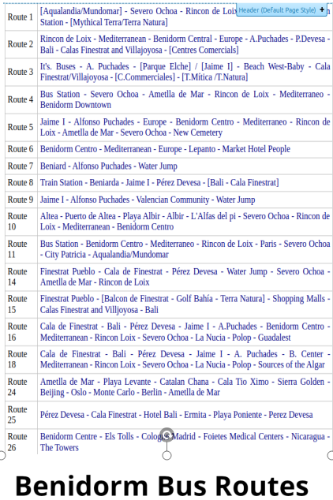
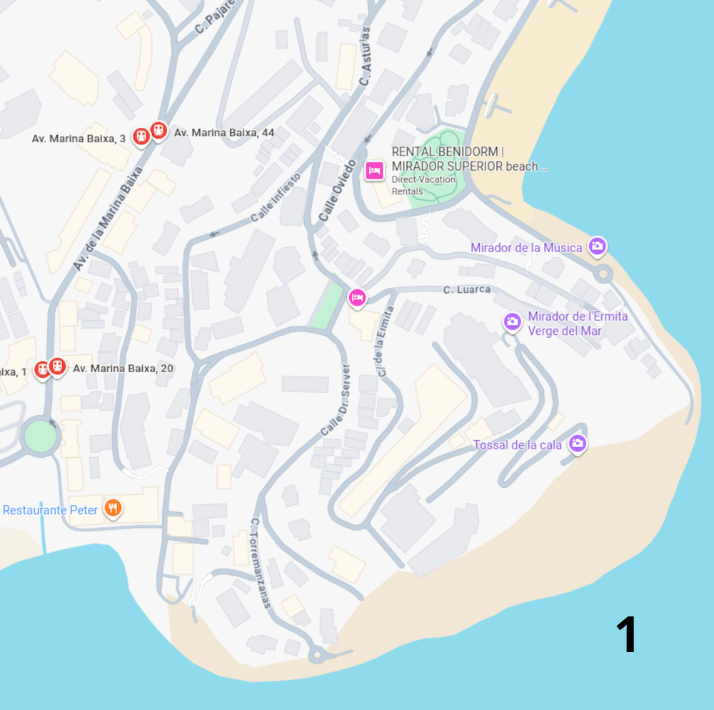
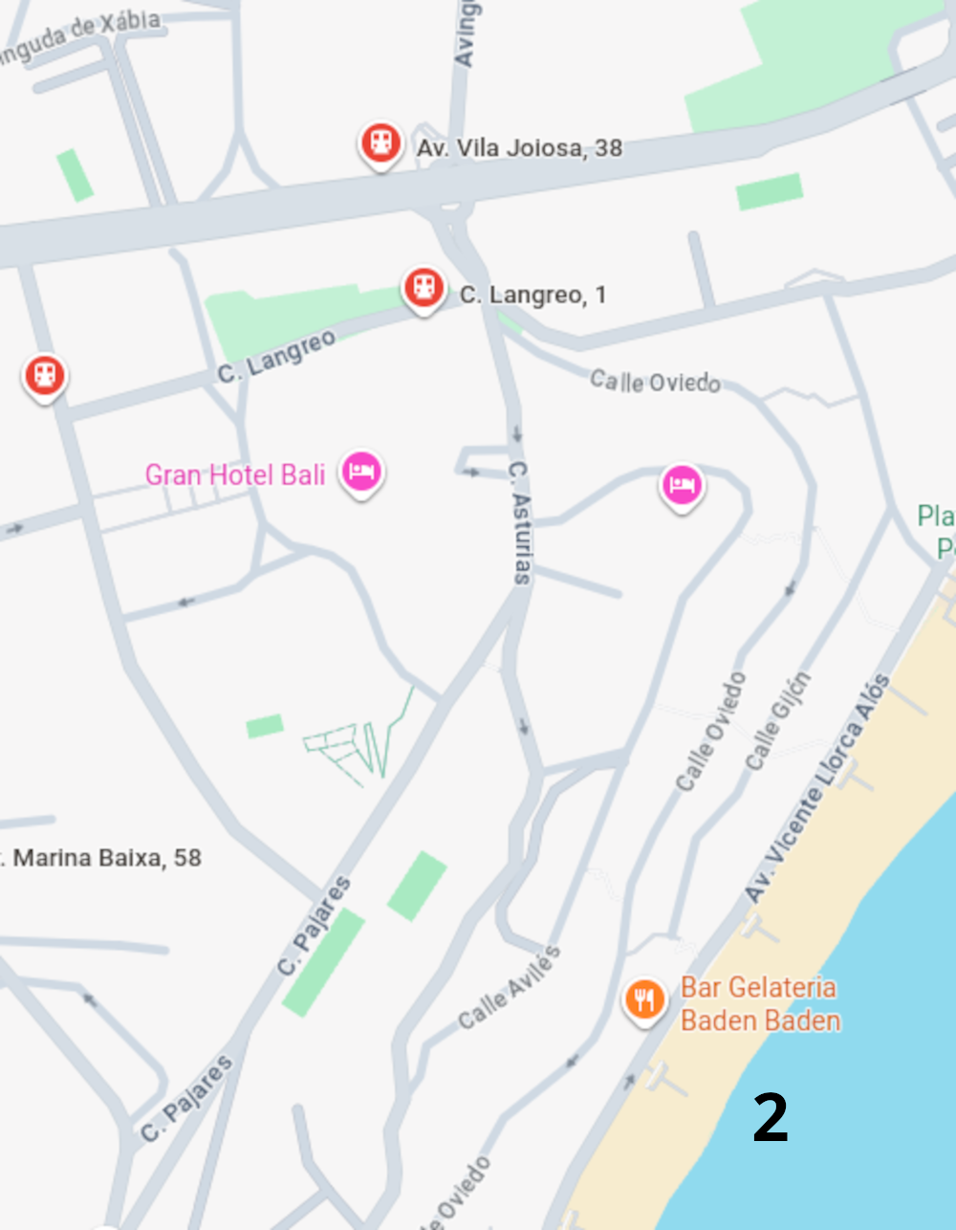
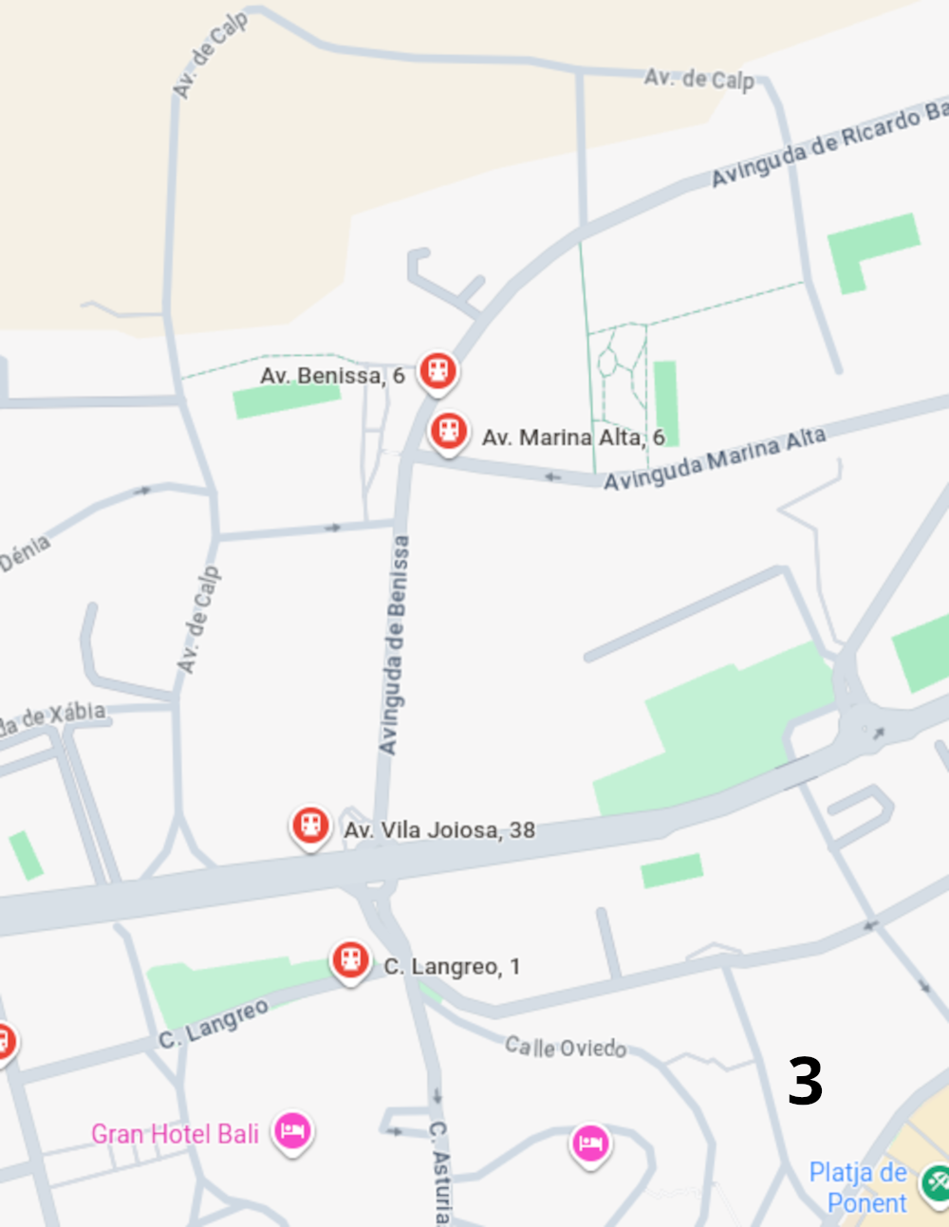
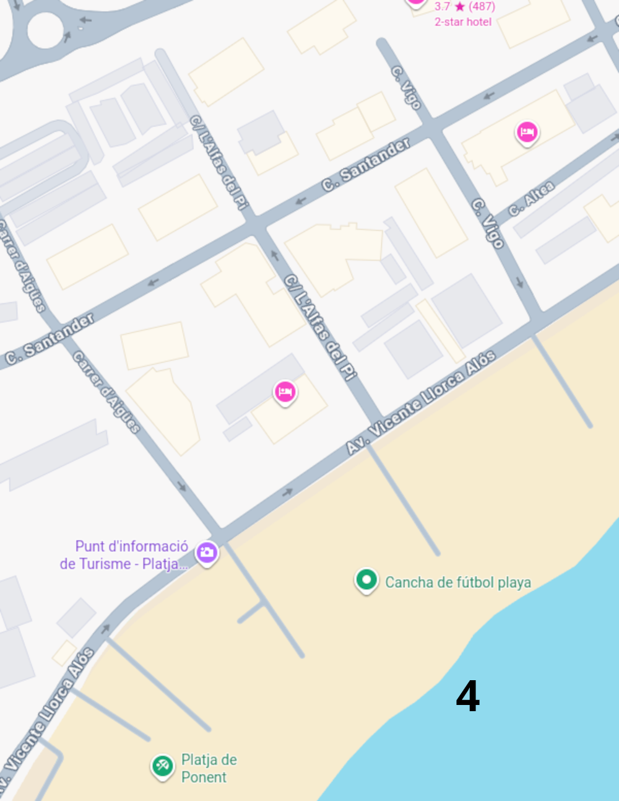
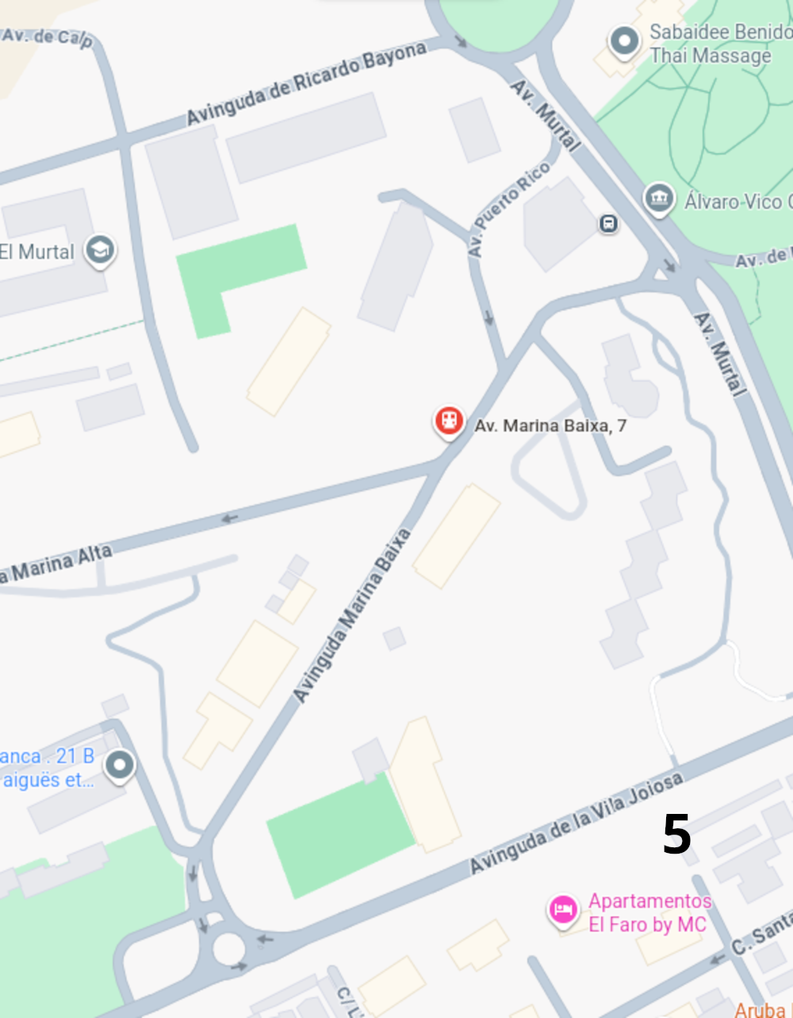
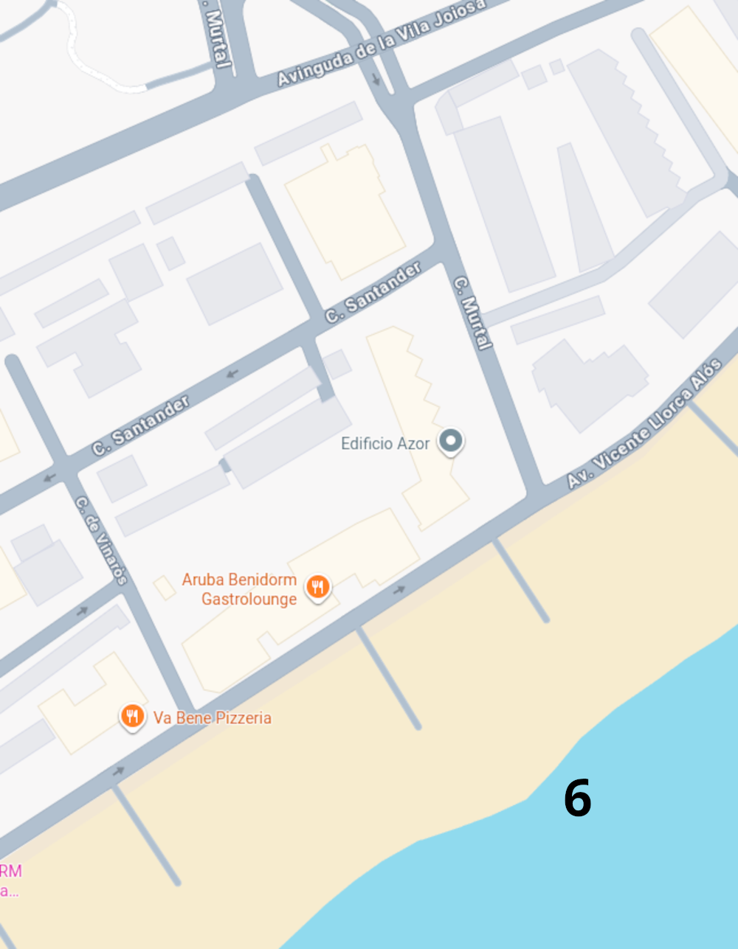
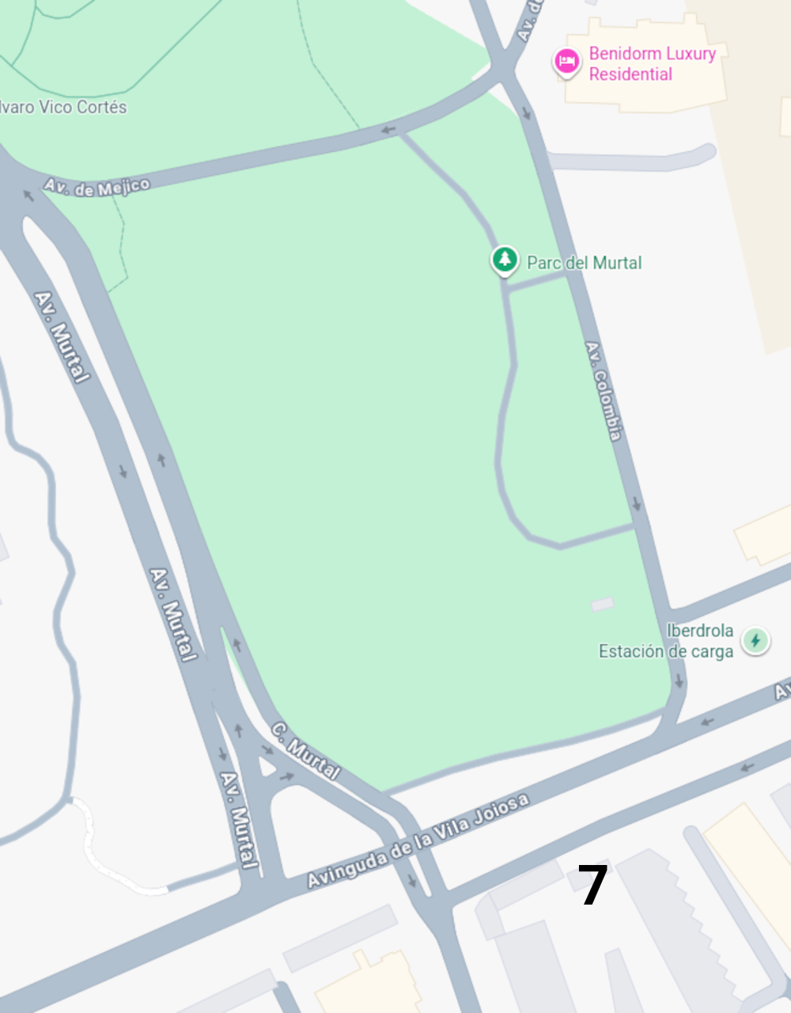
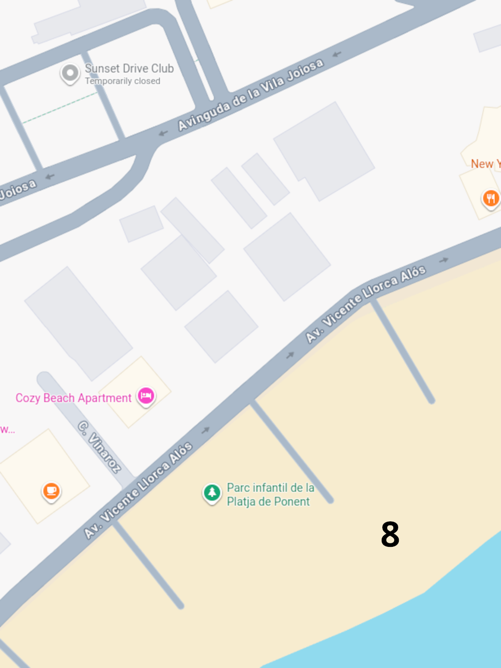
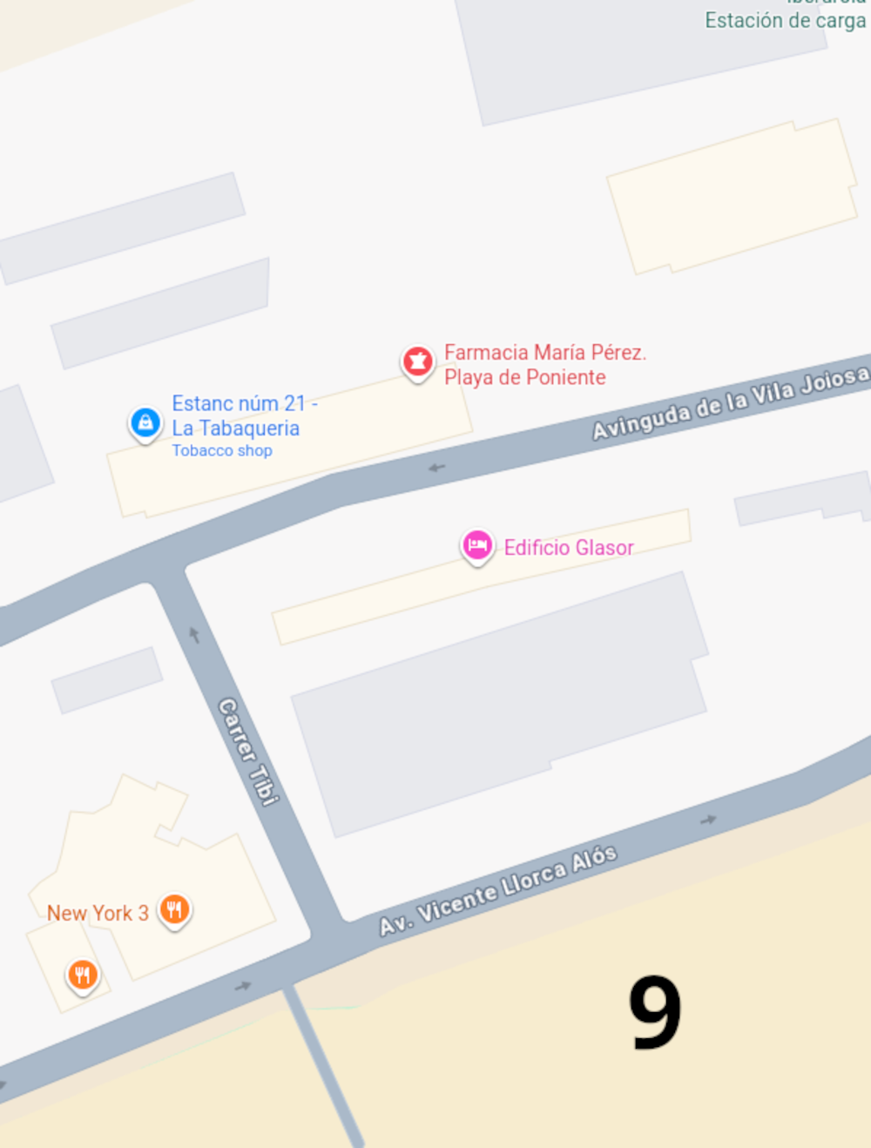
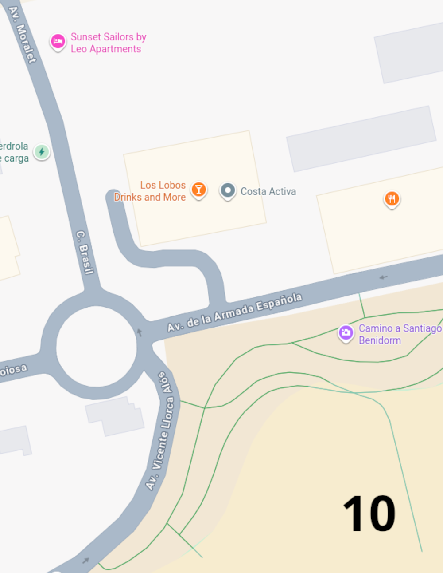
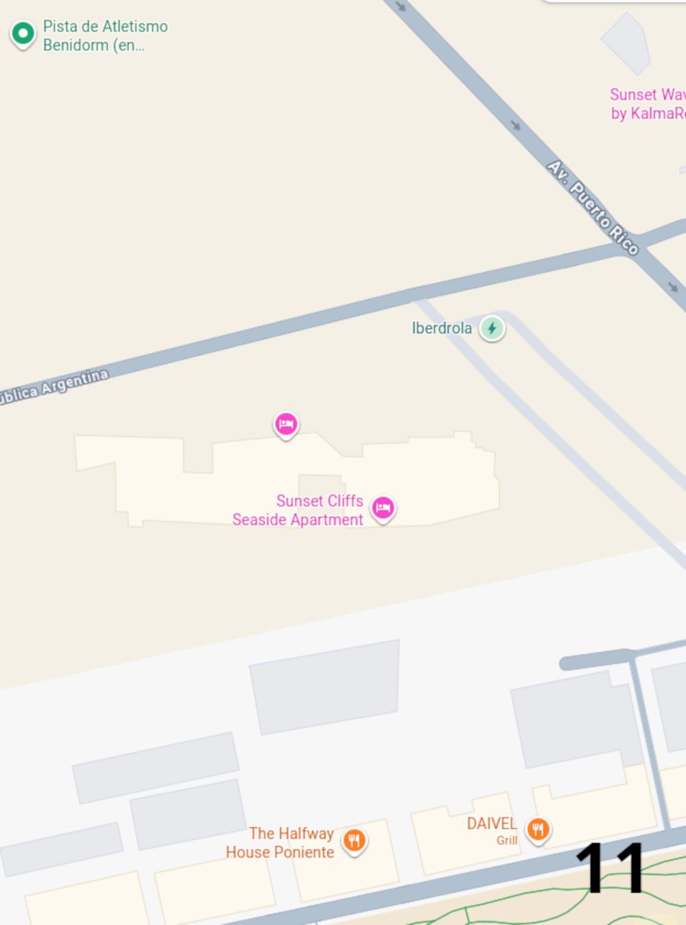
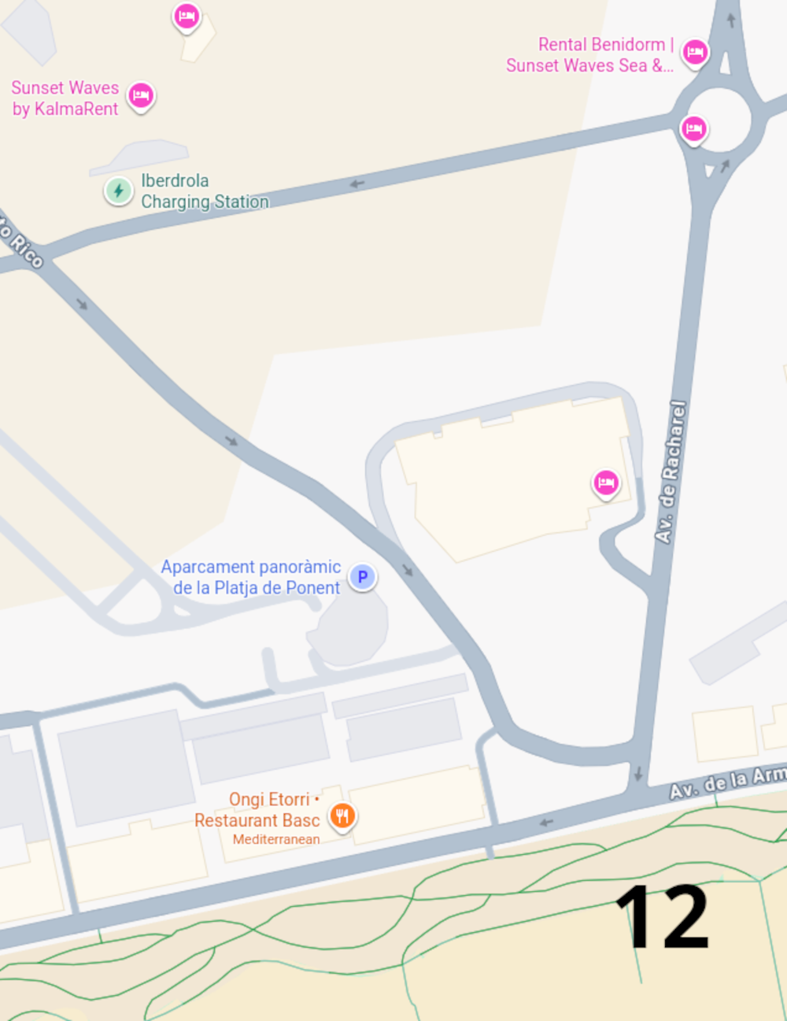
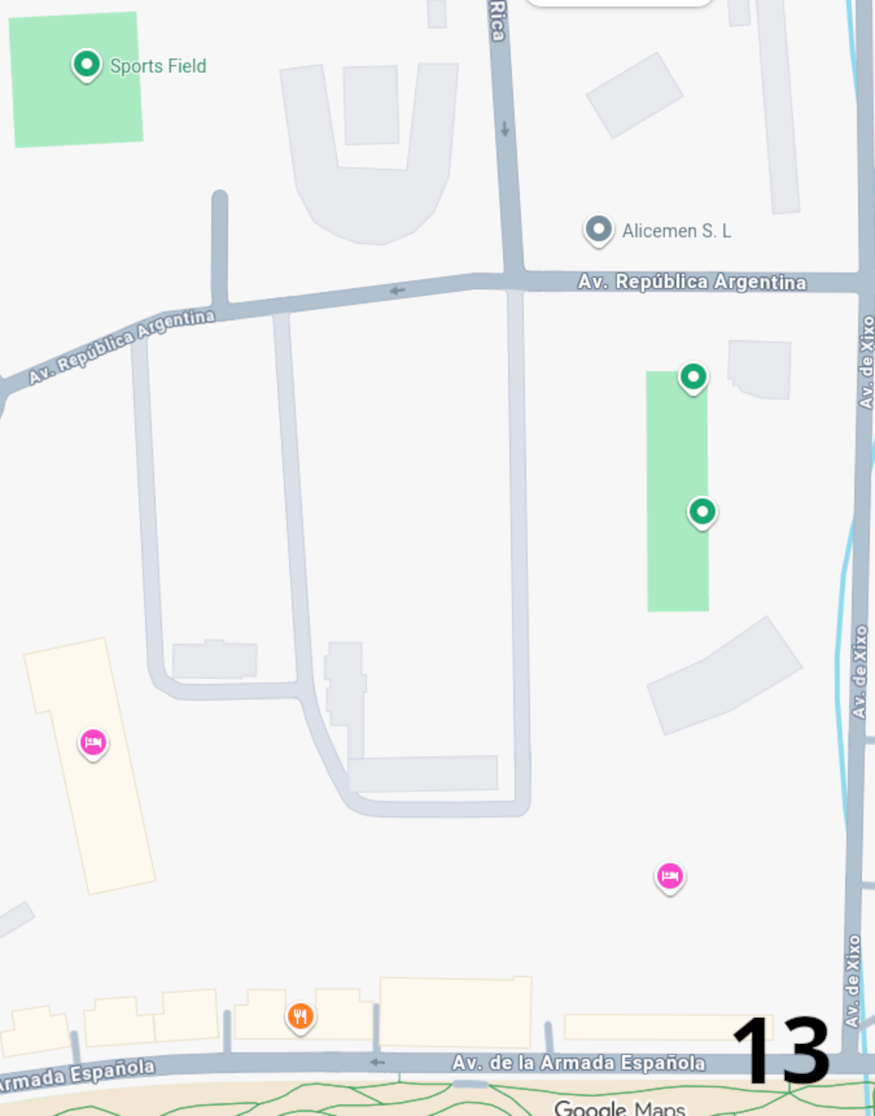
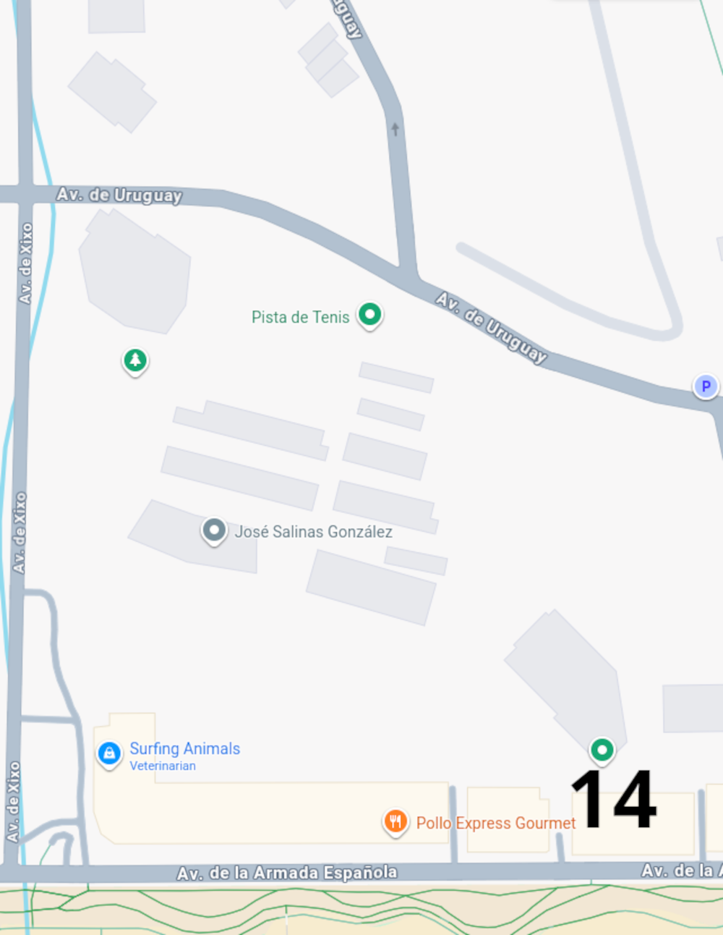
Page 13

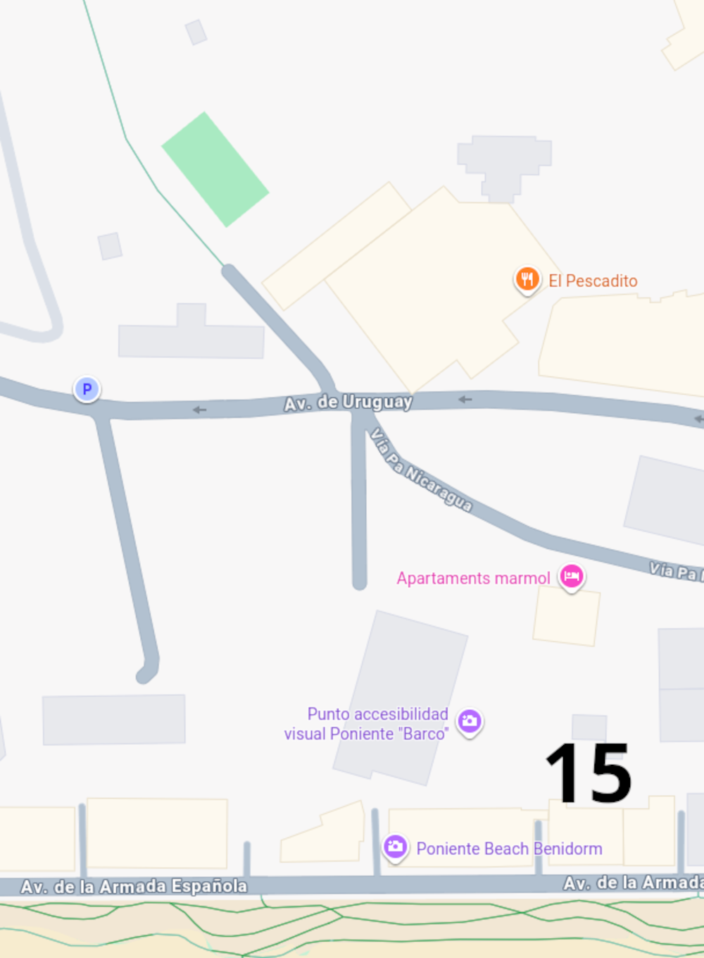

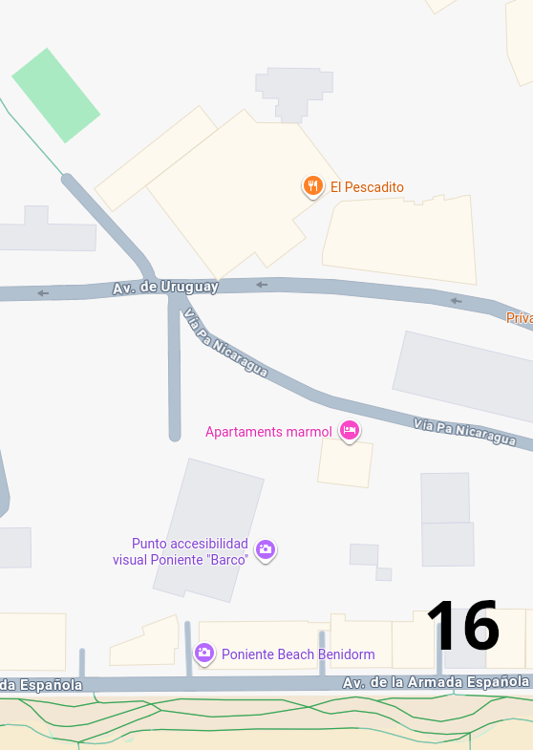
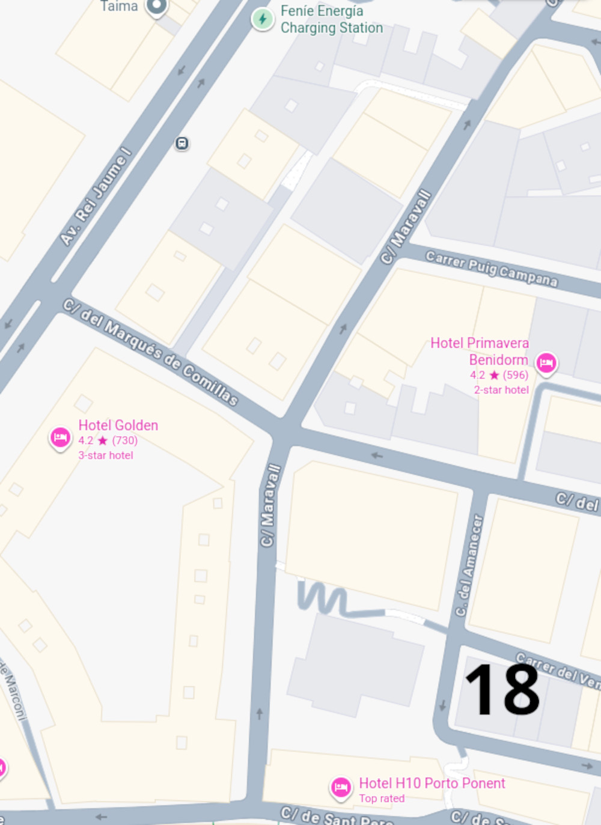
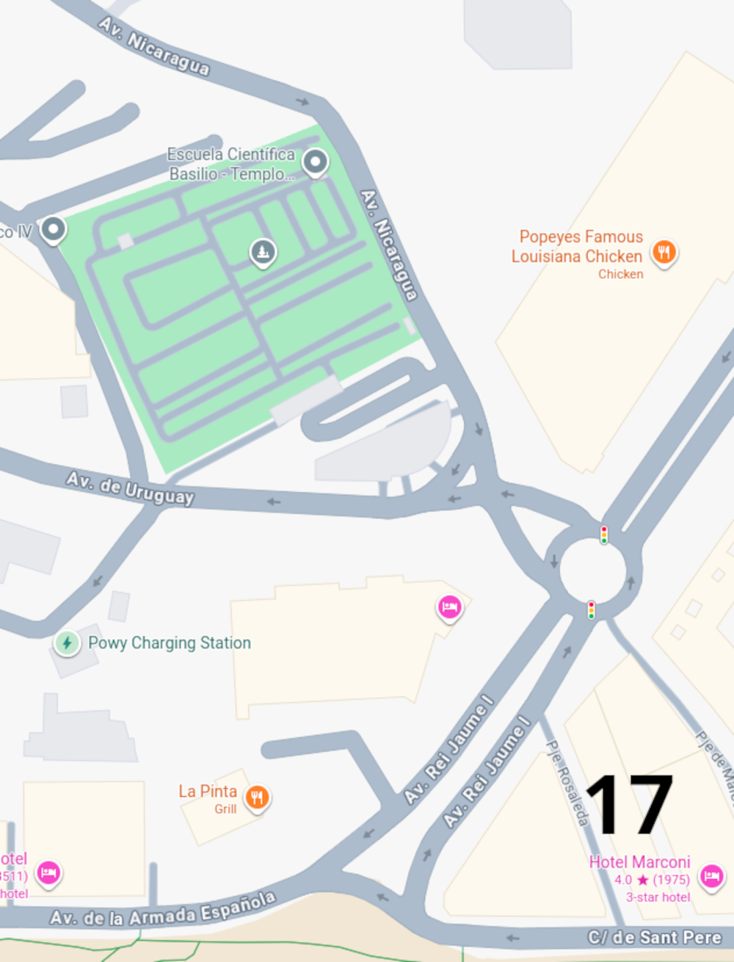
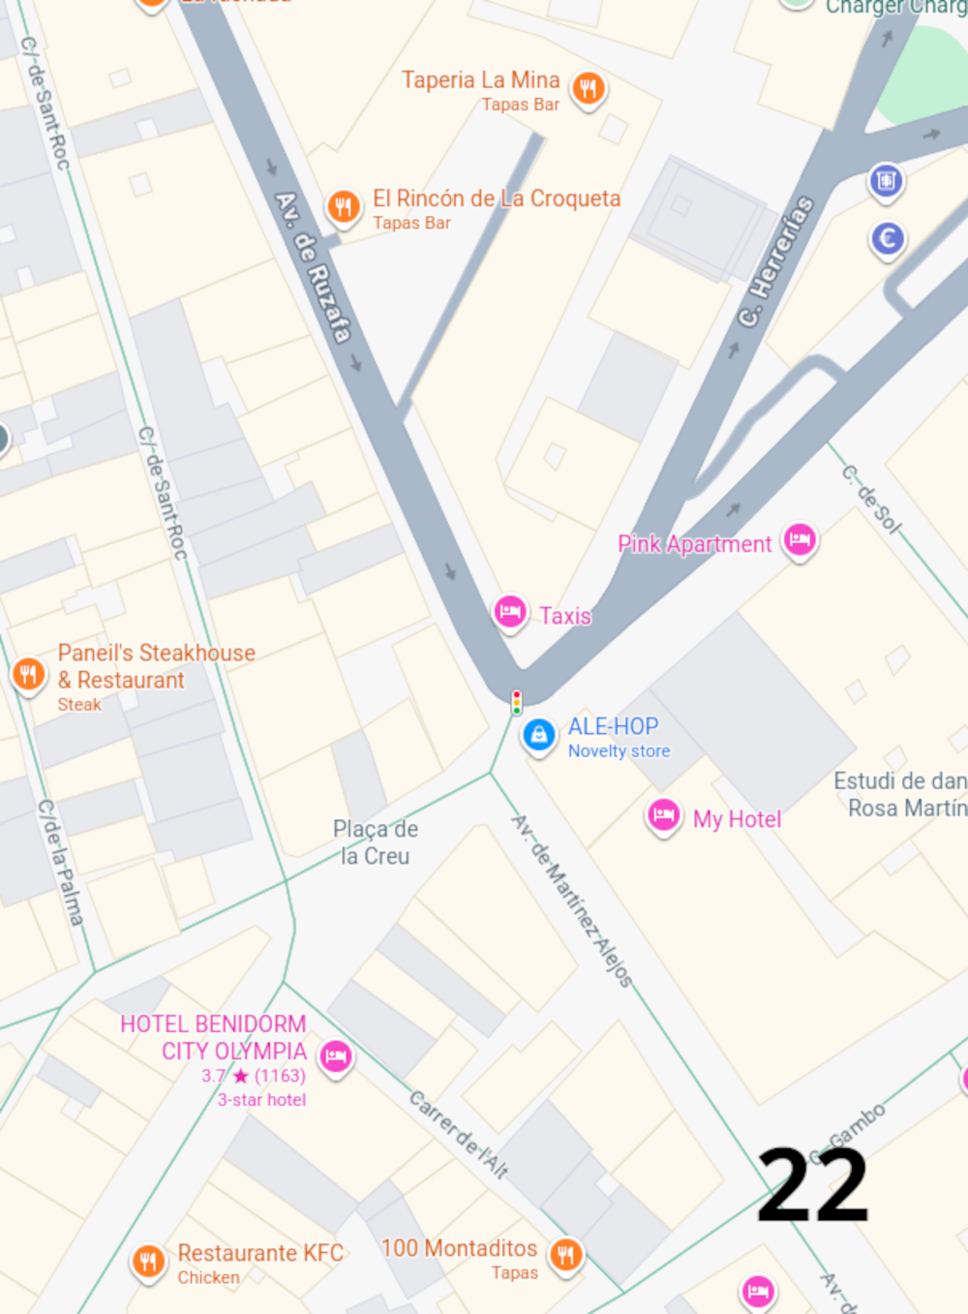
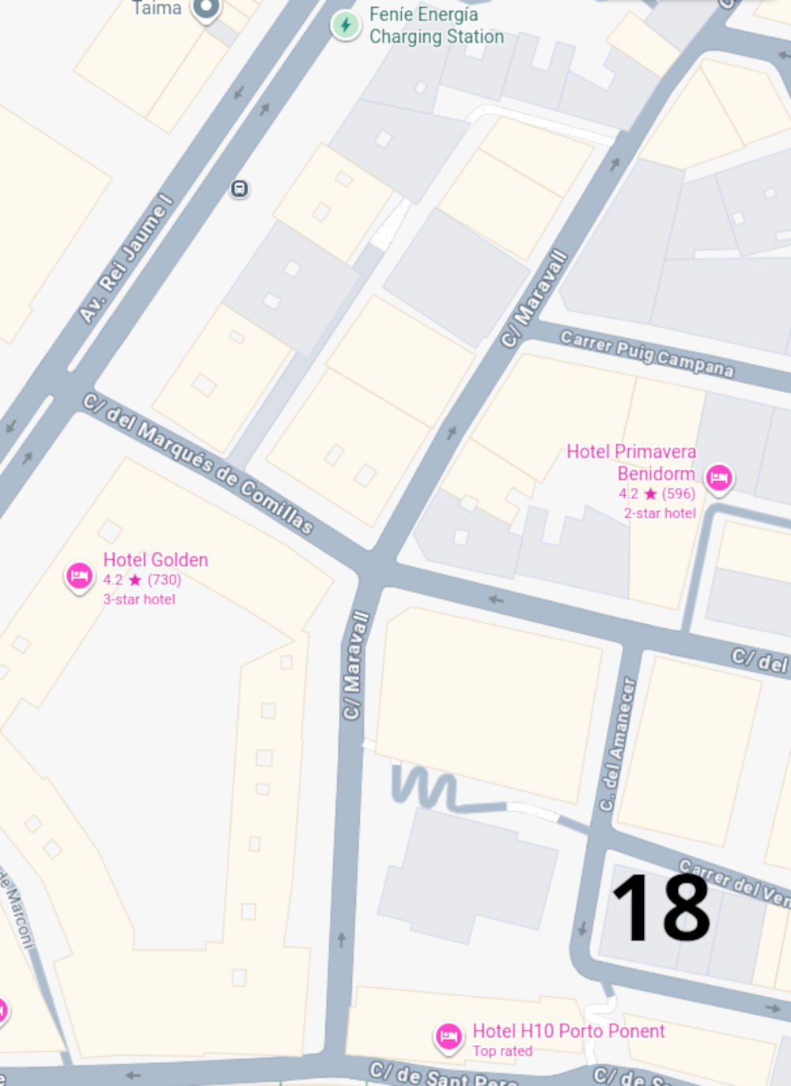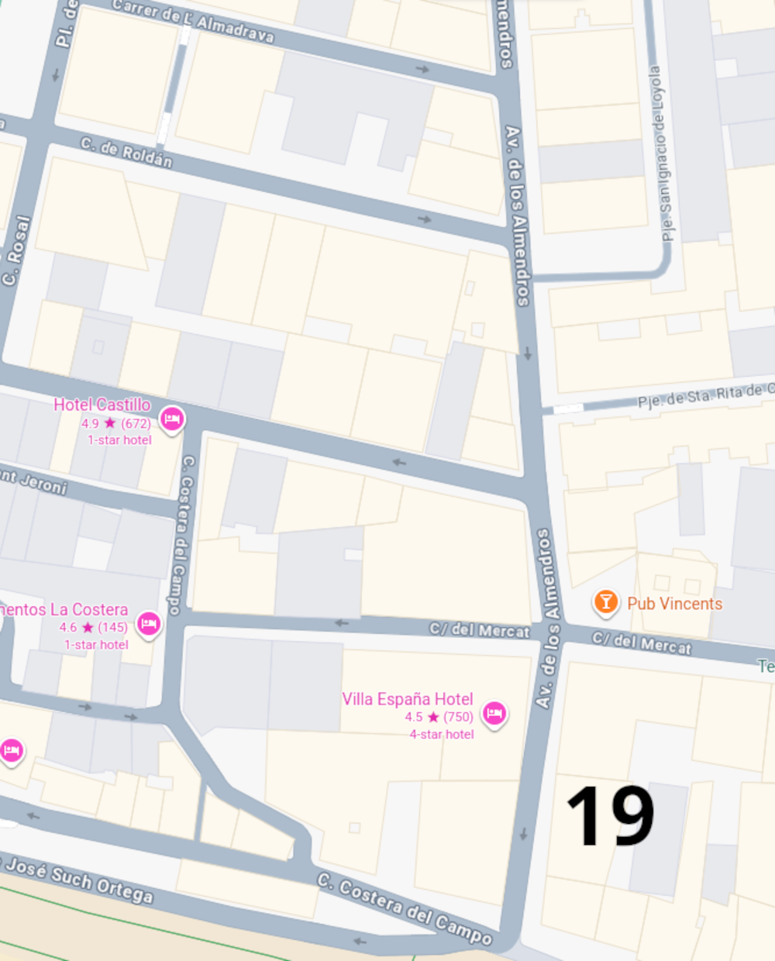
Page 17
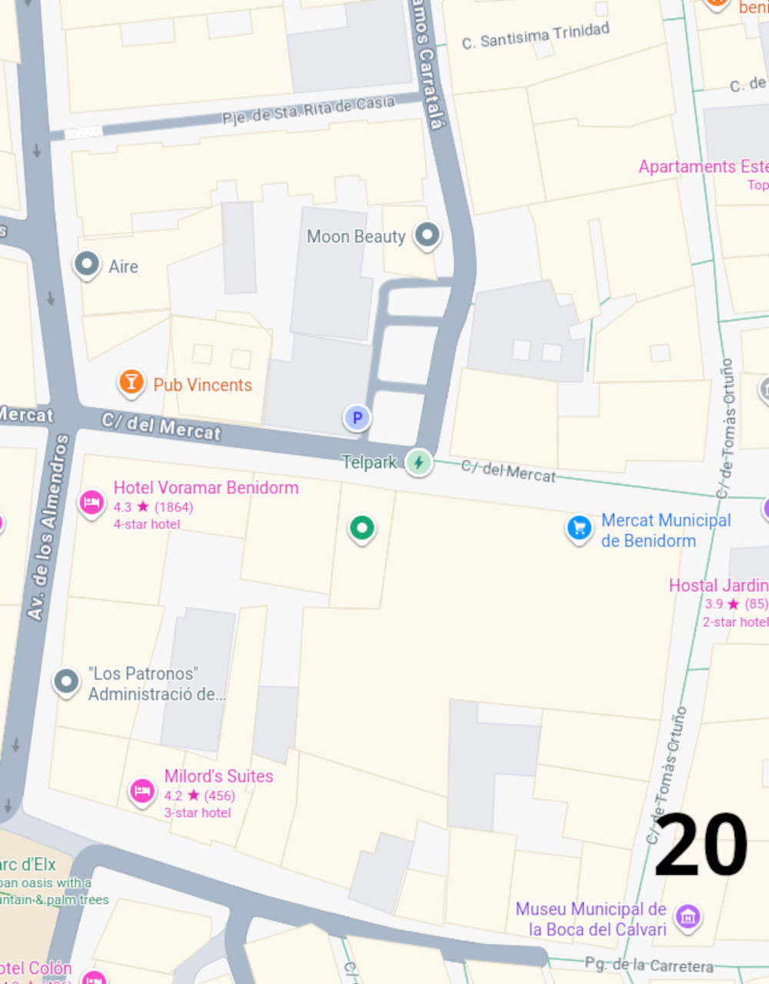
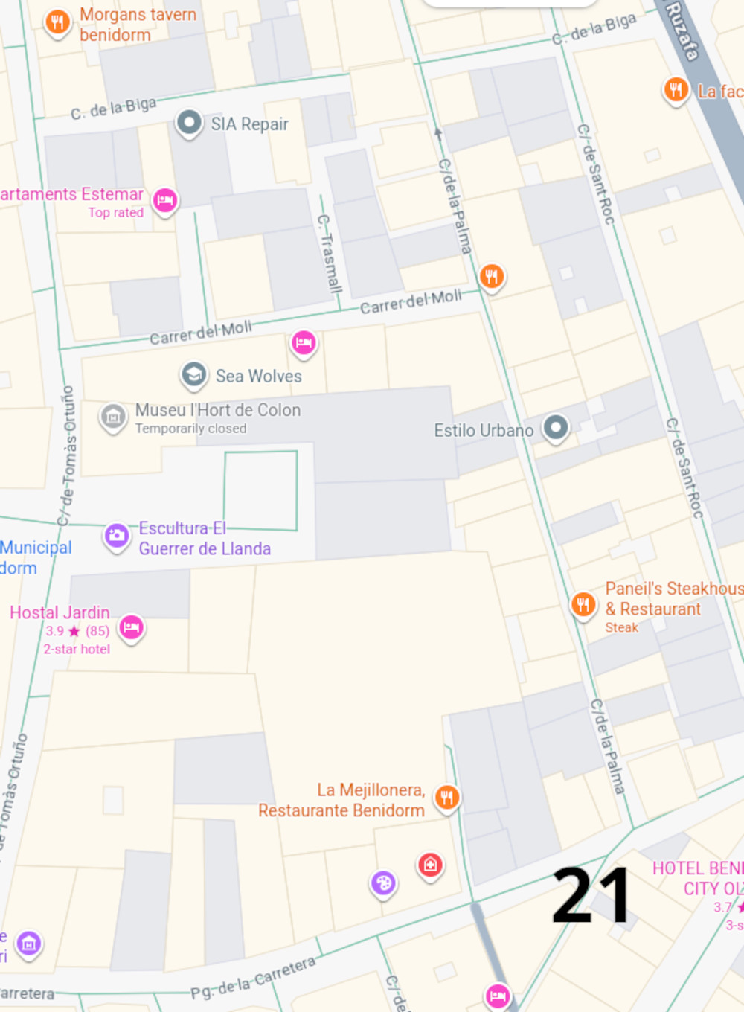
in tet
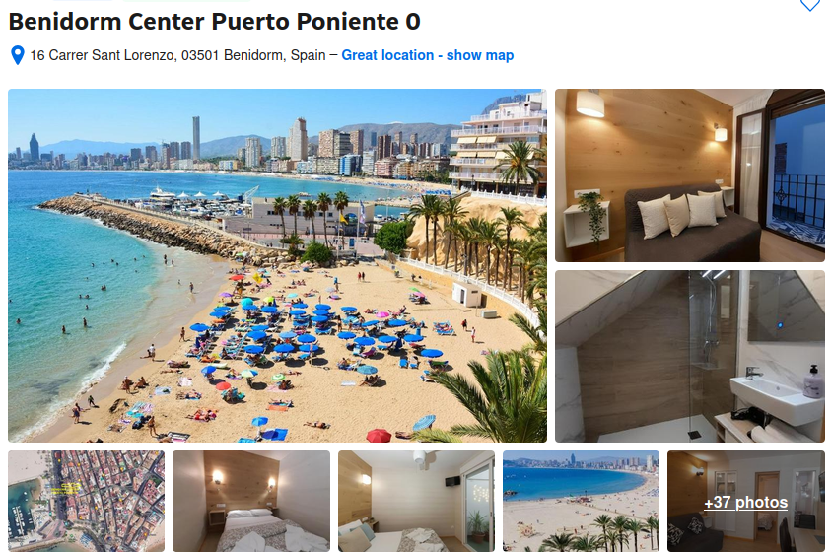

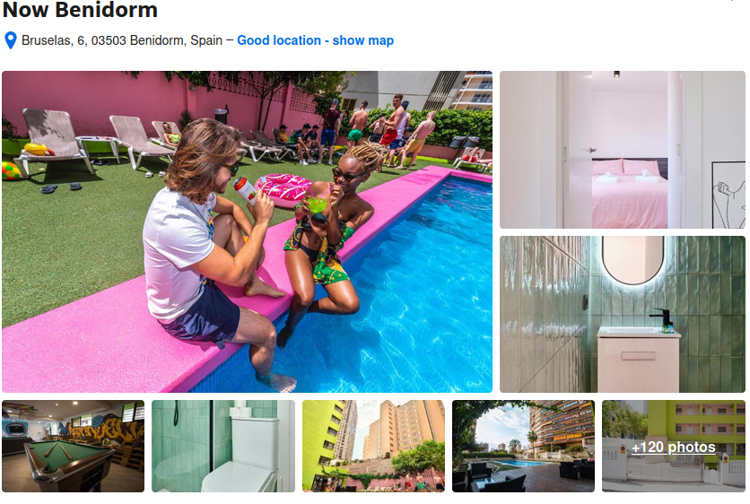
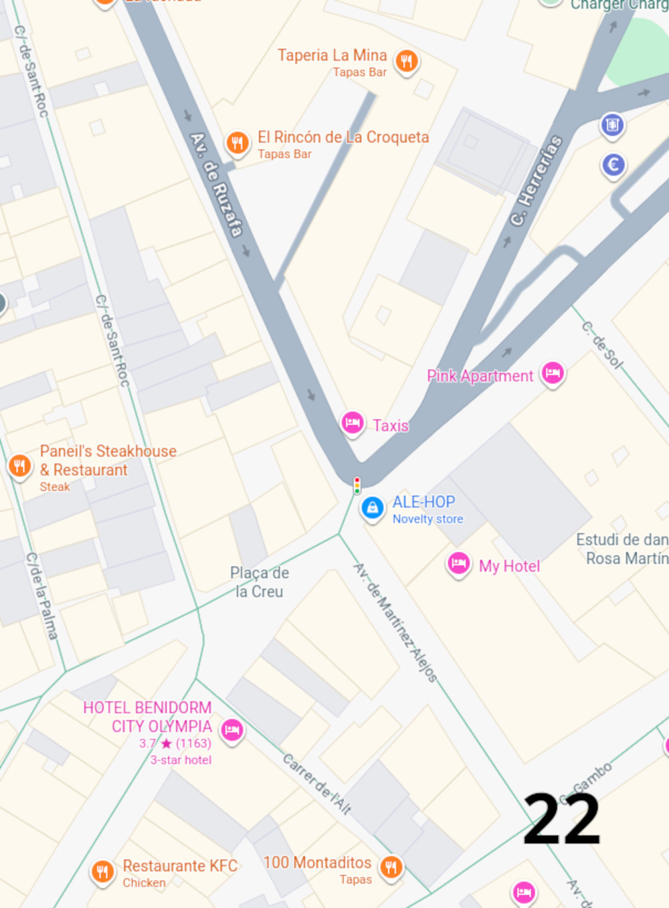
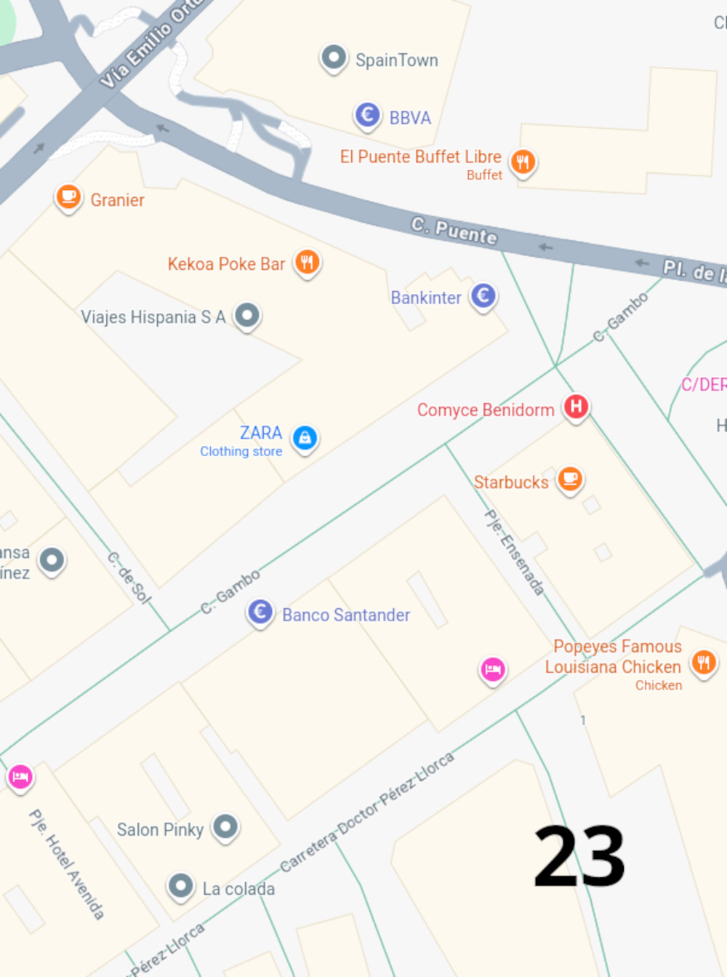
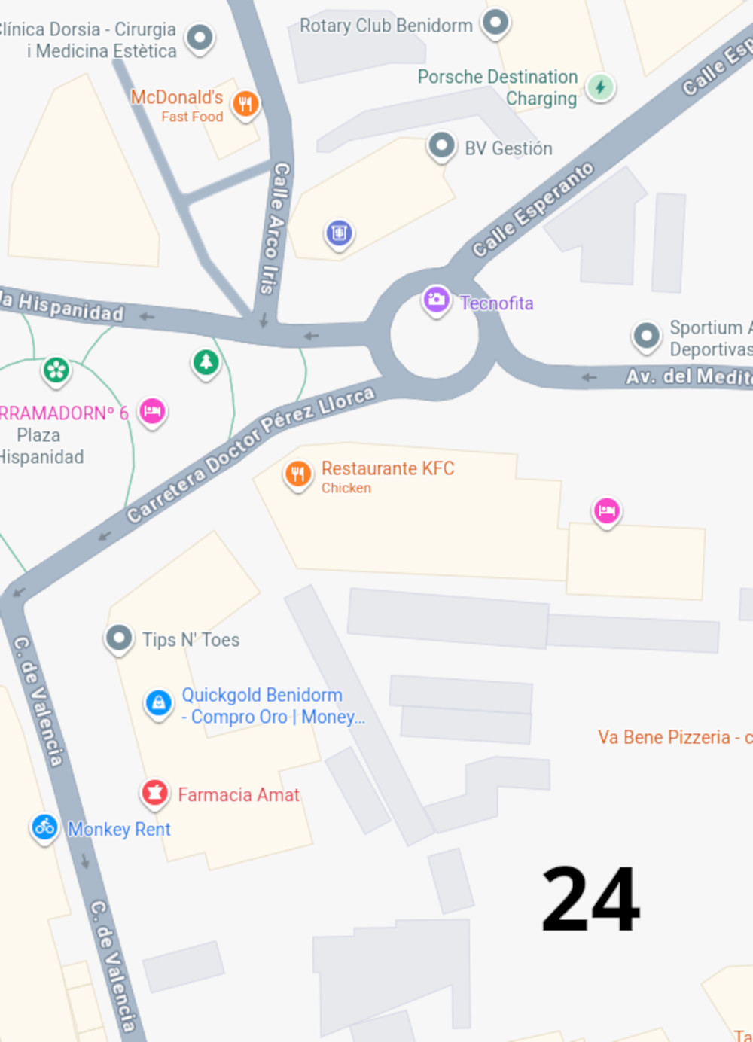
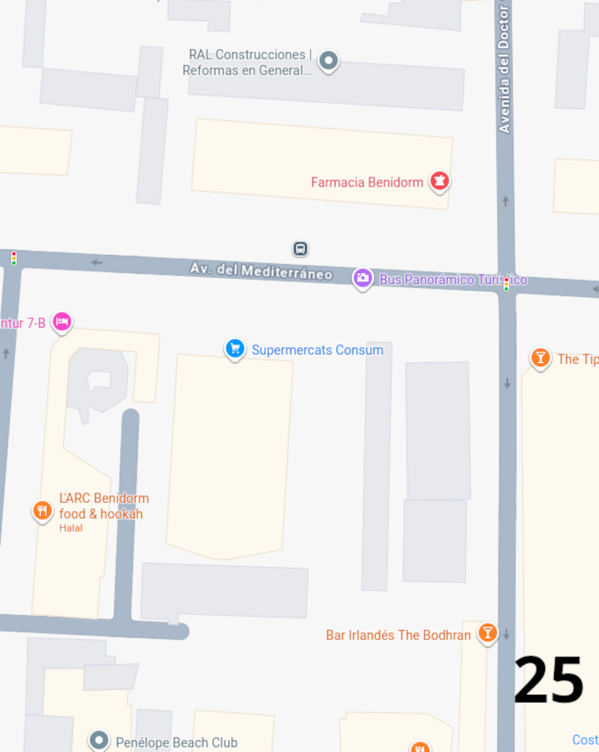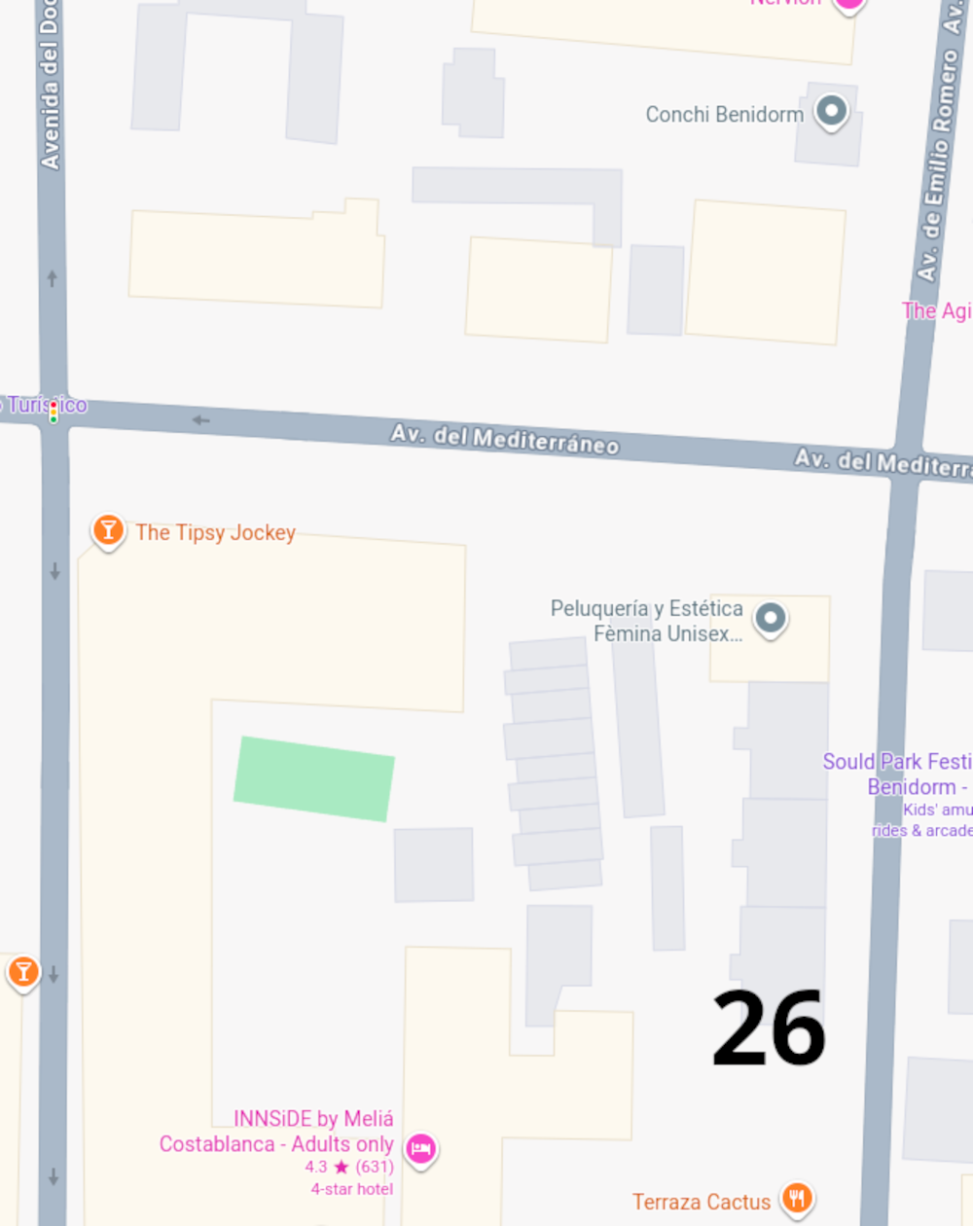
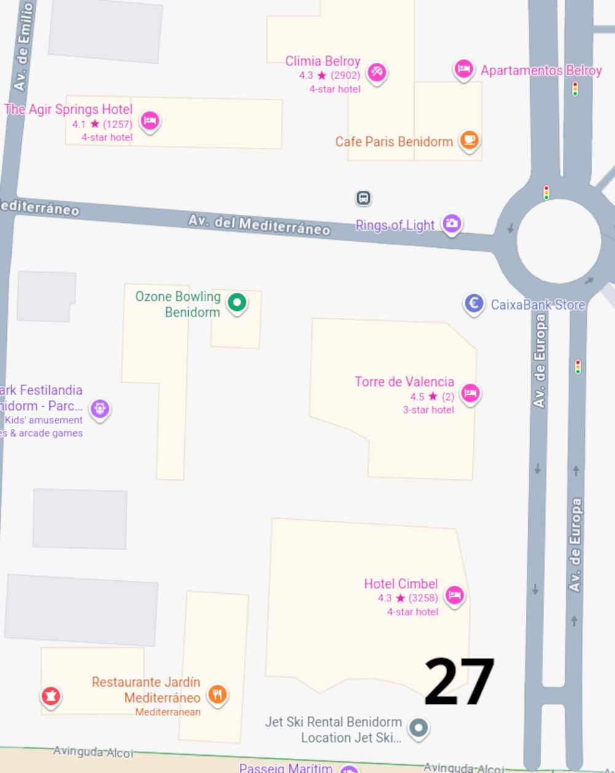
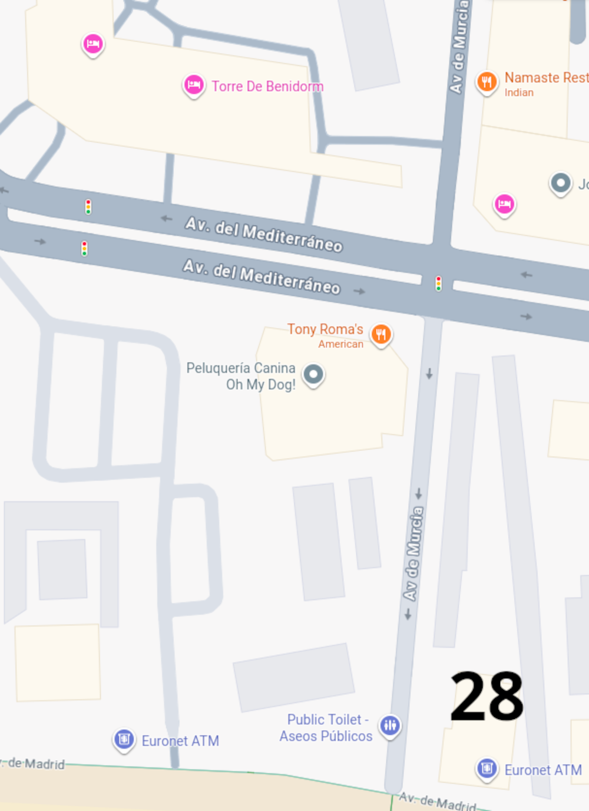
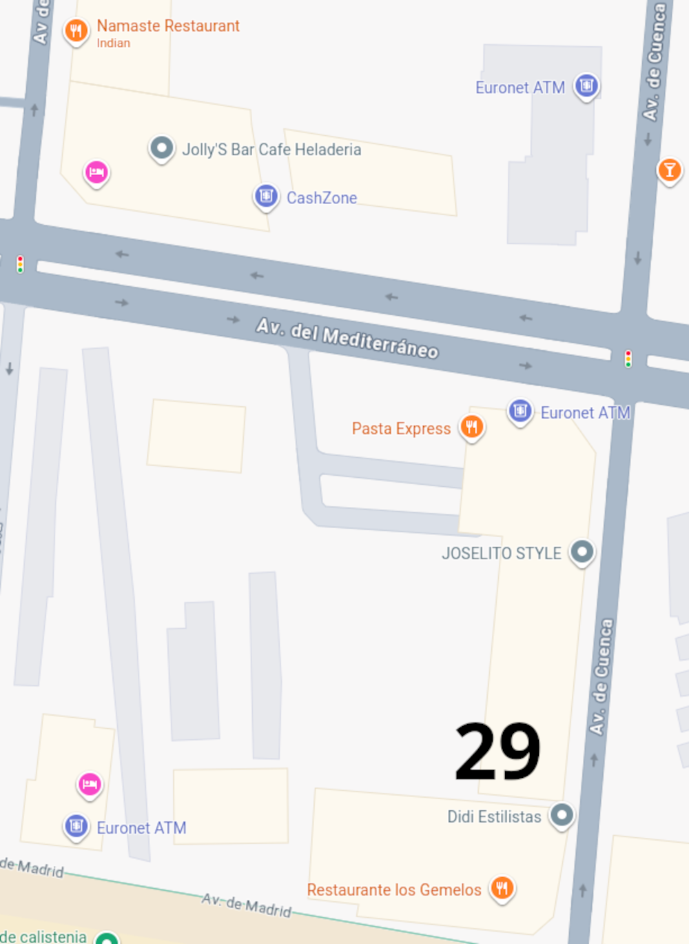
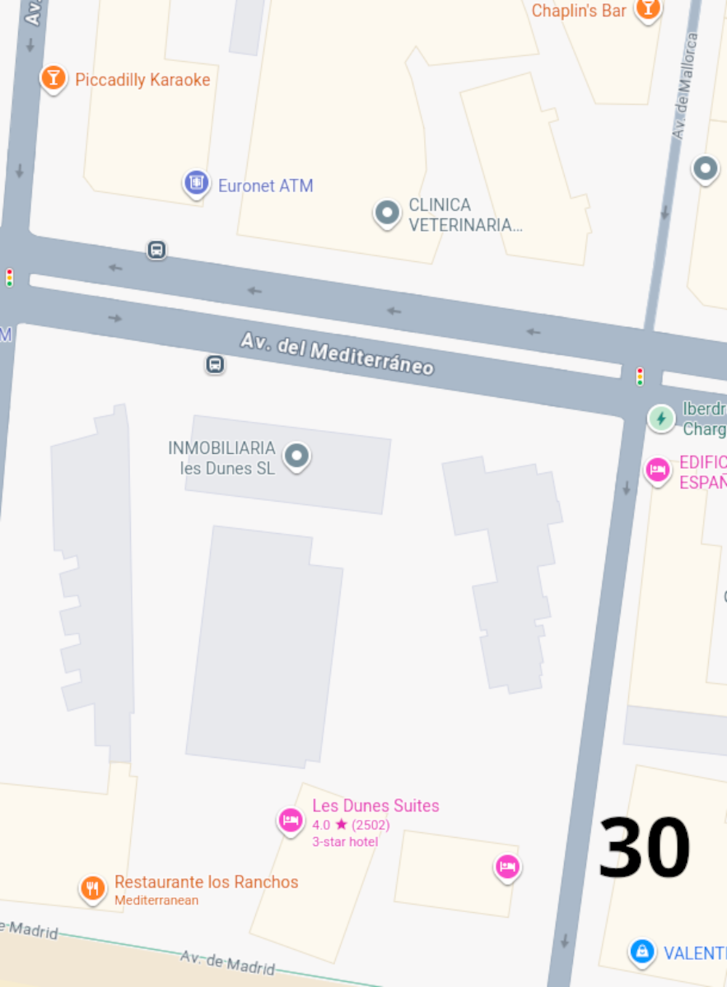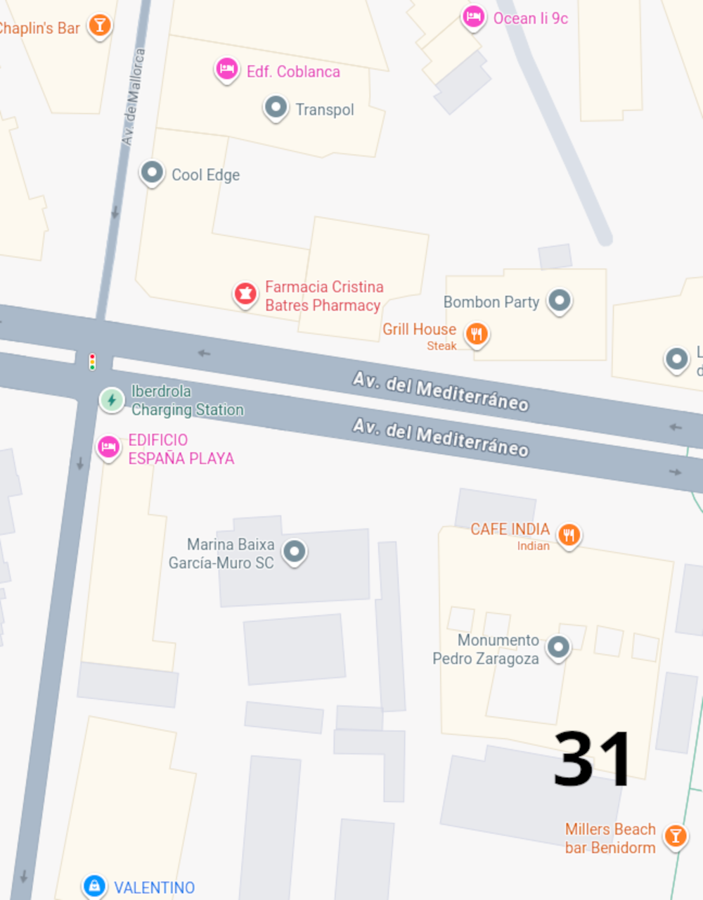
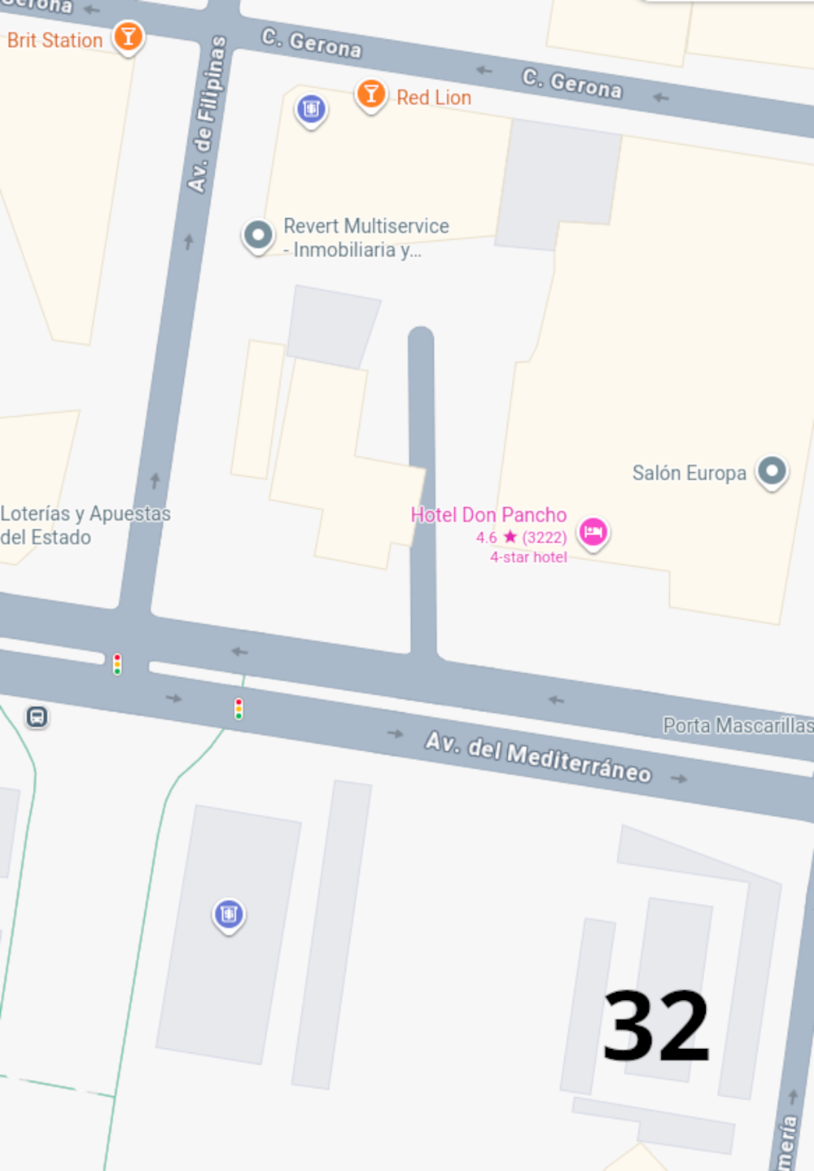
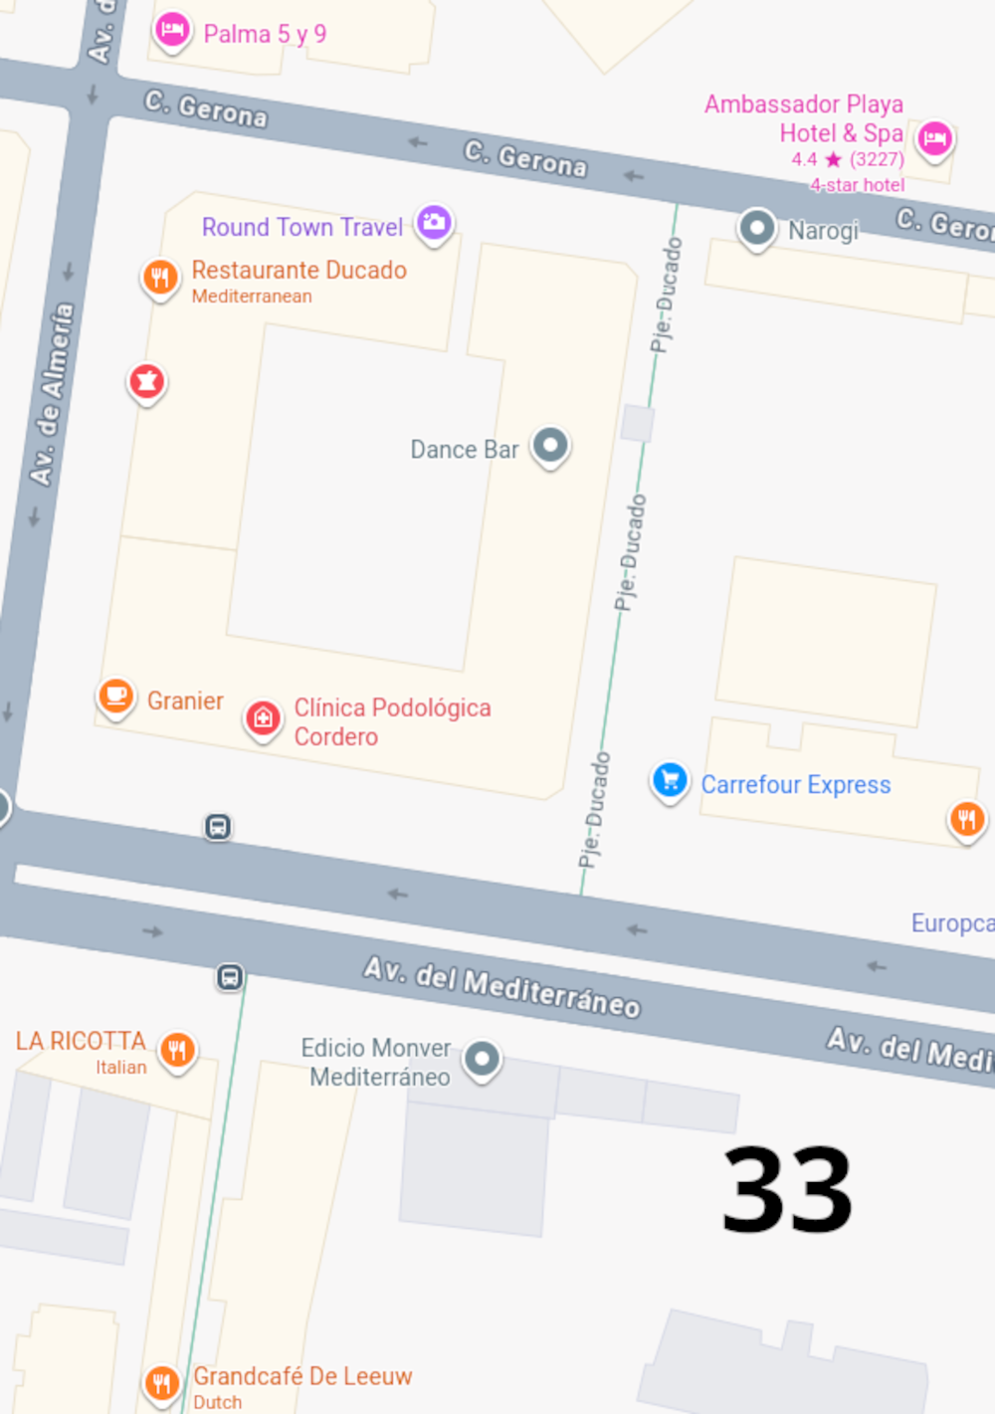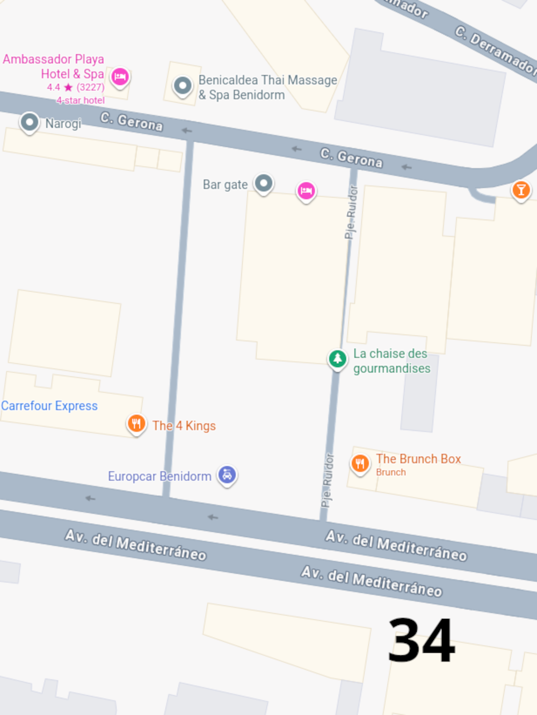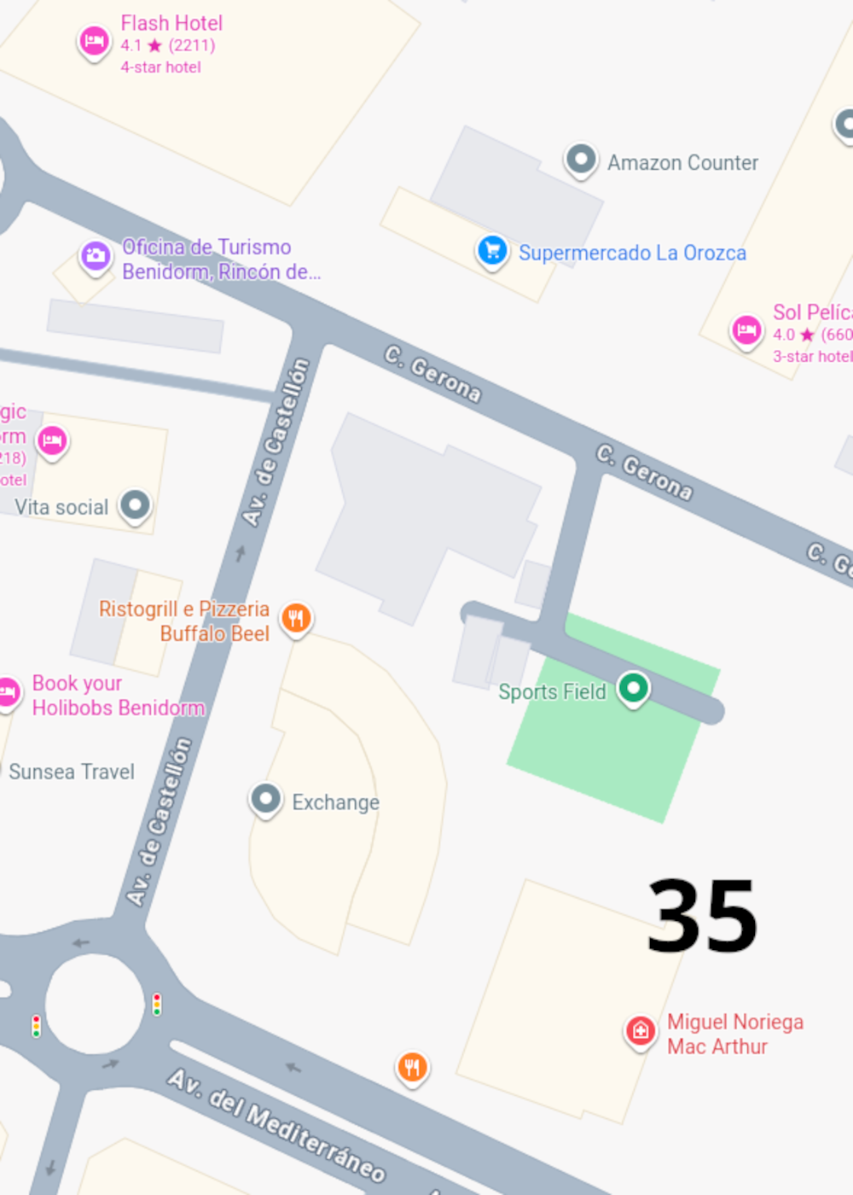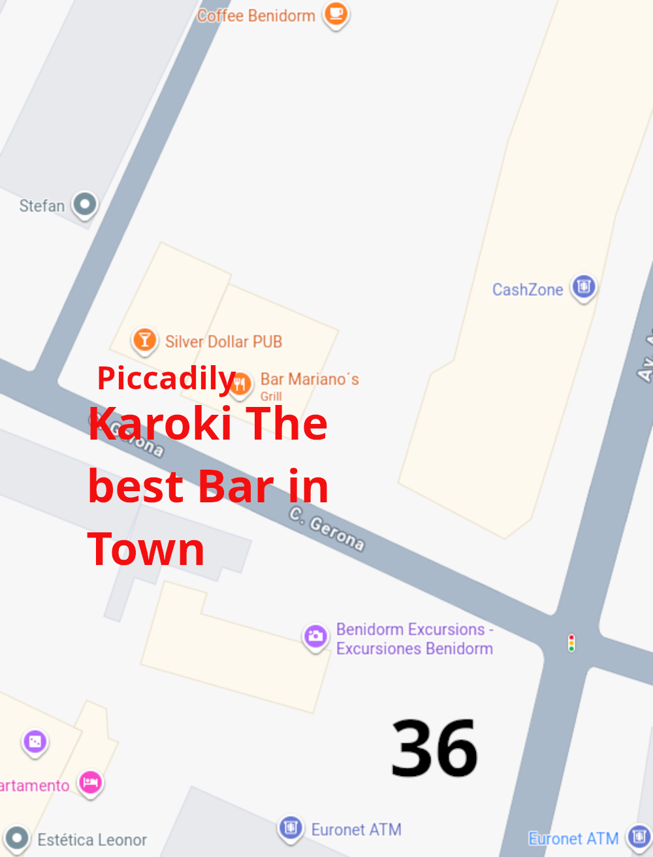
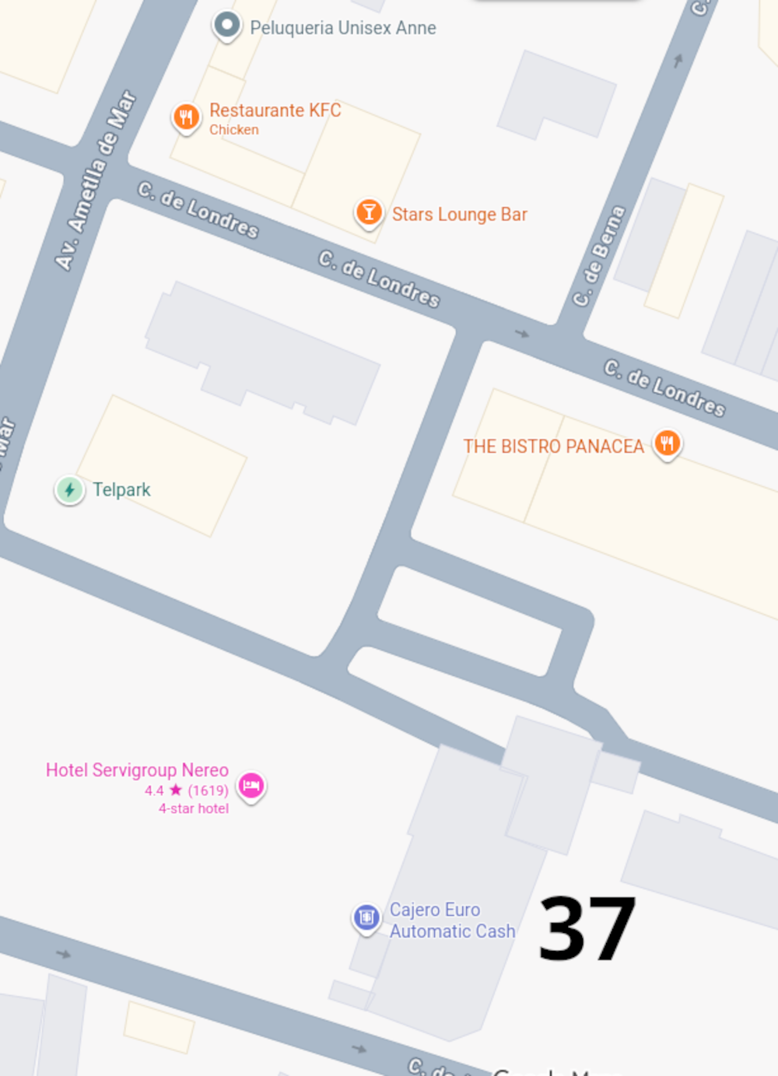
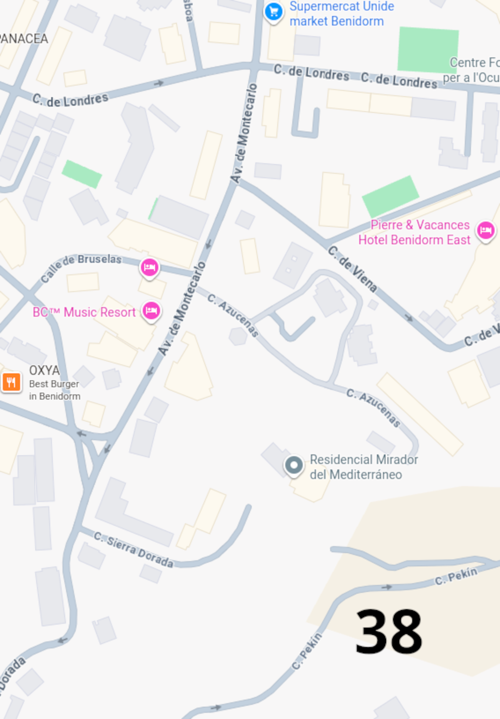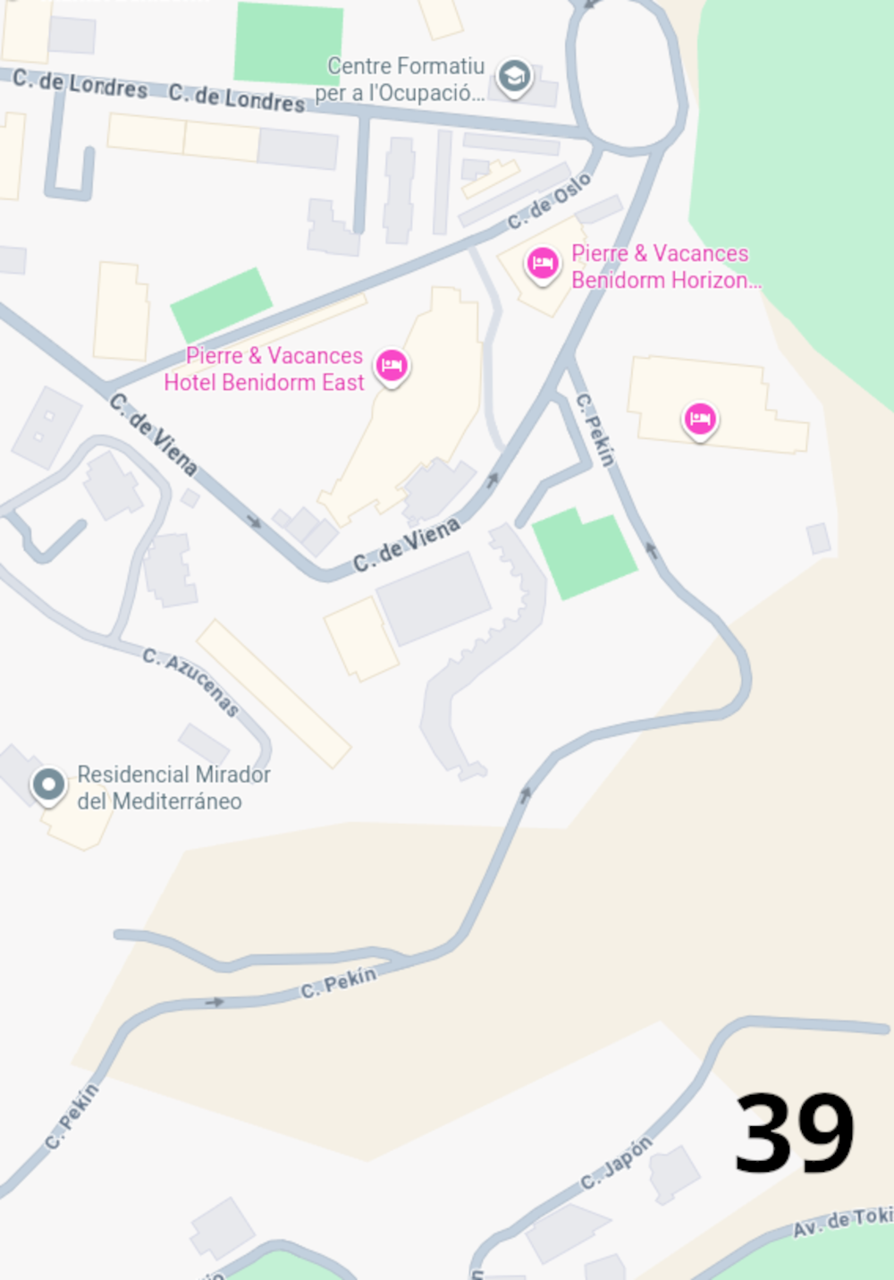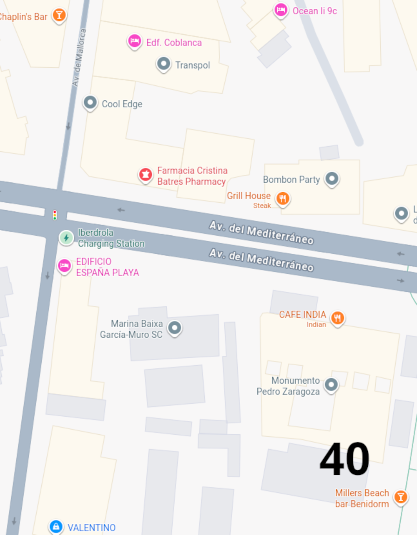
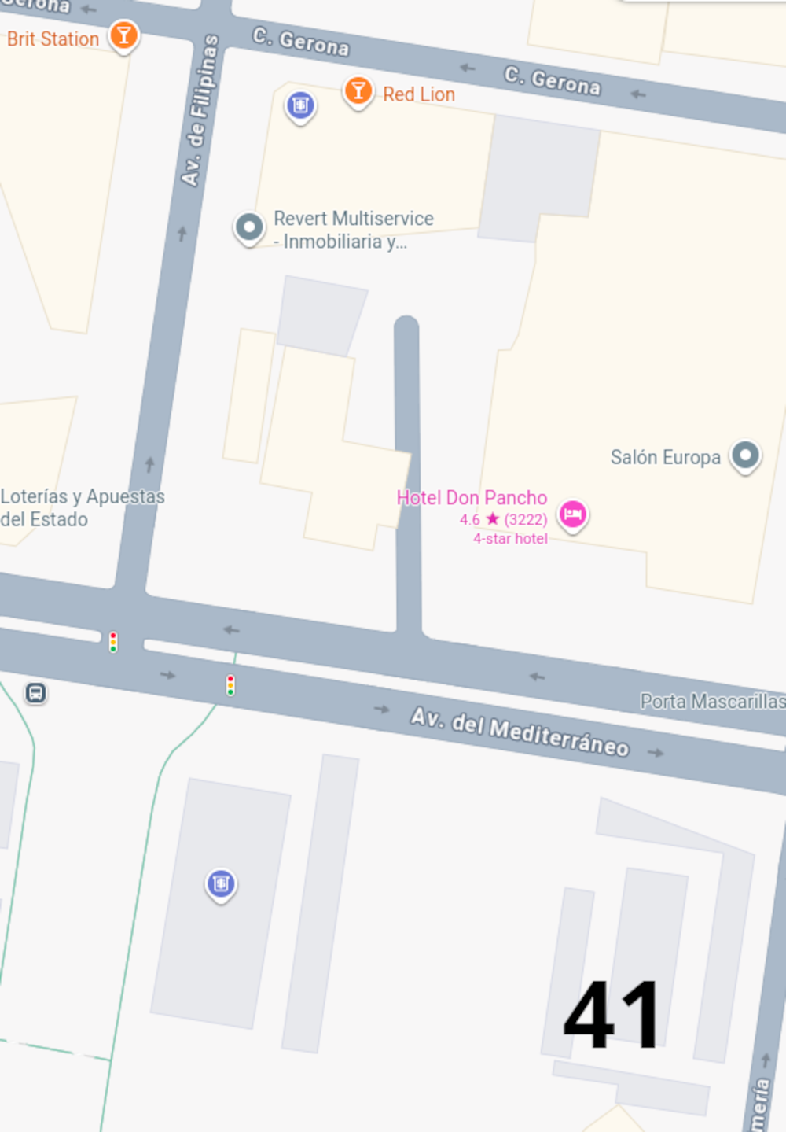
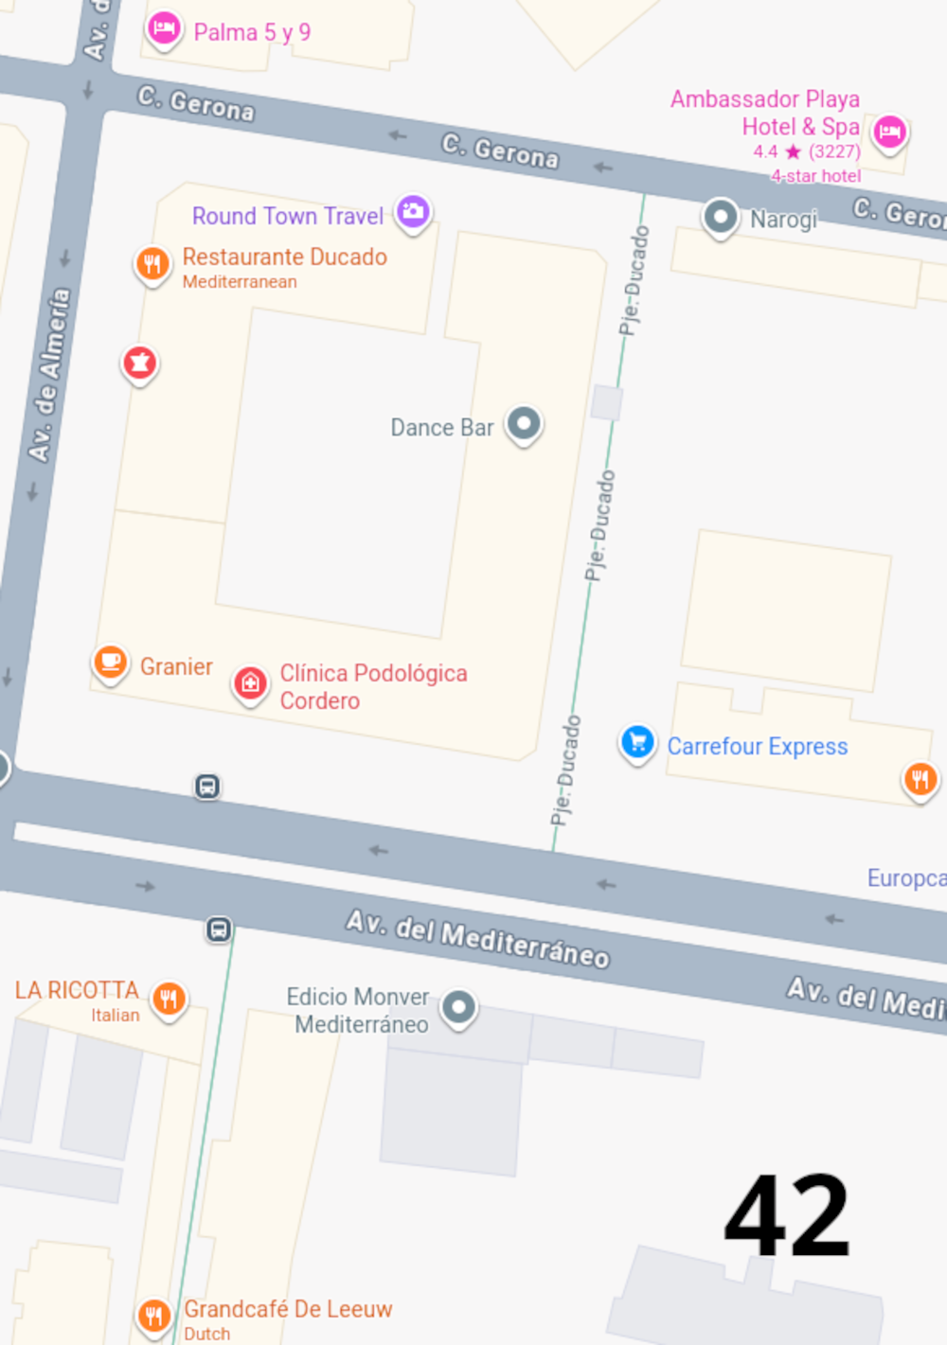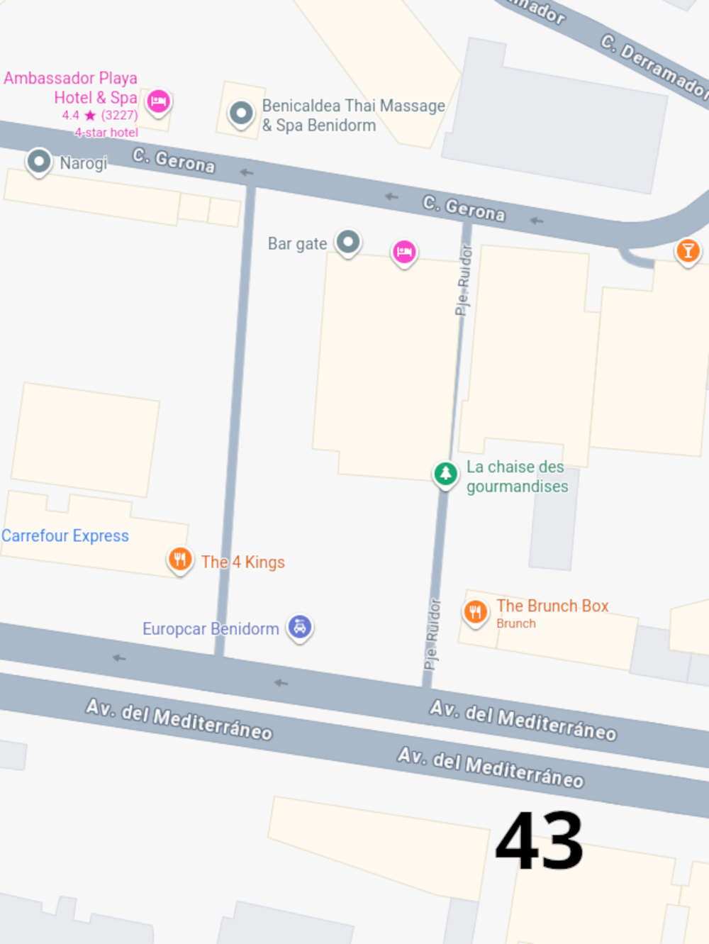
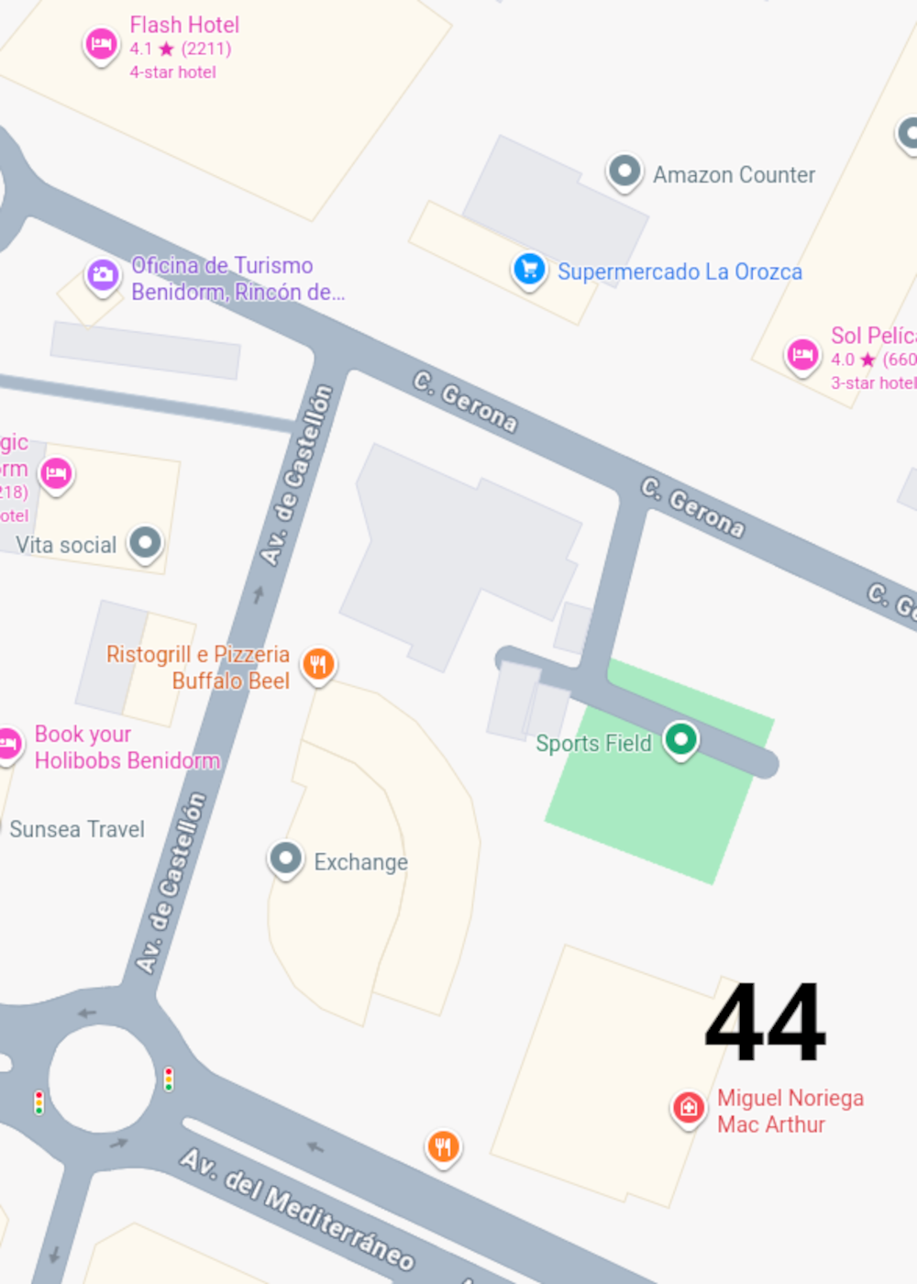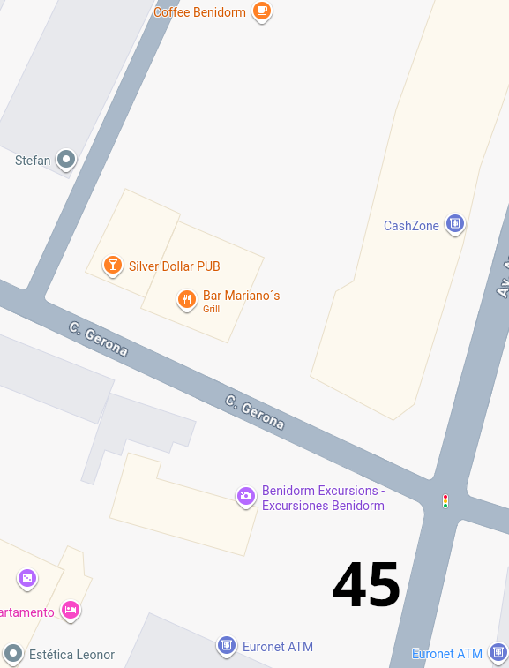
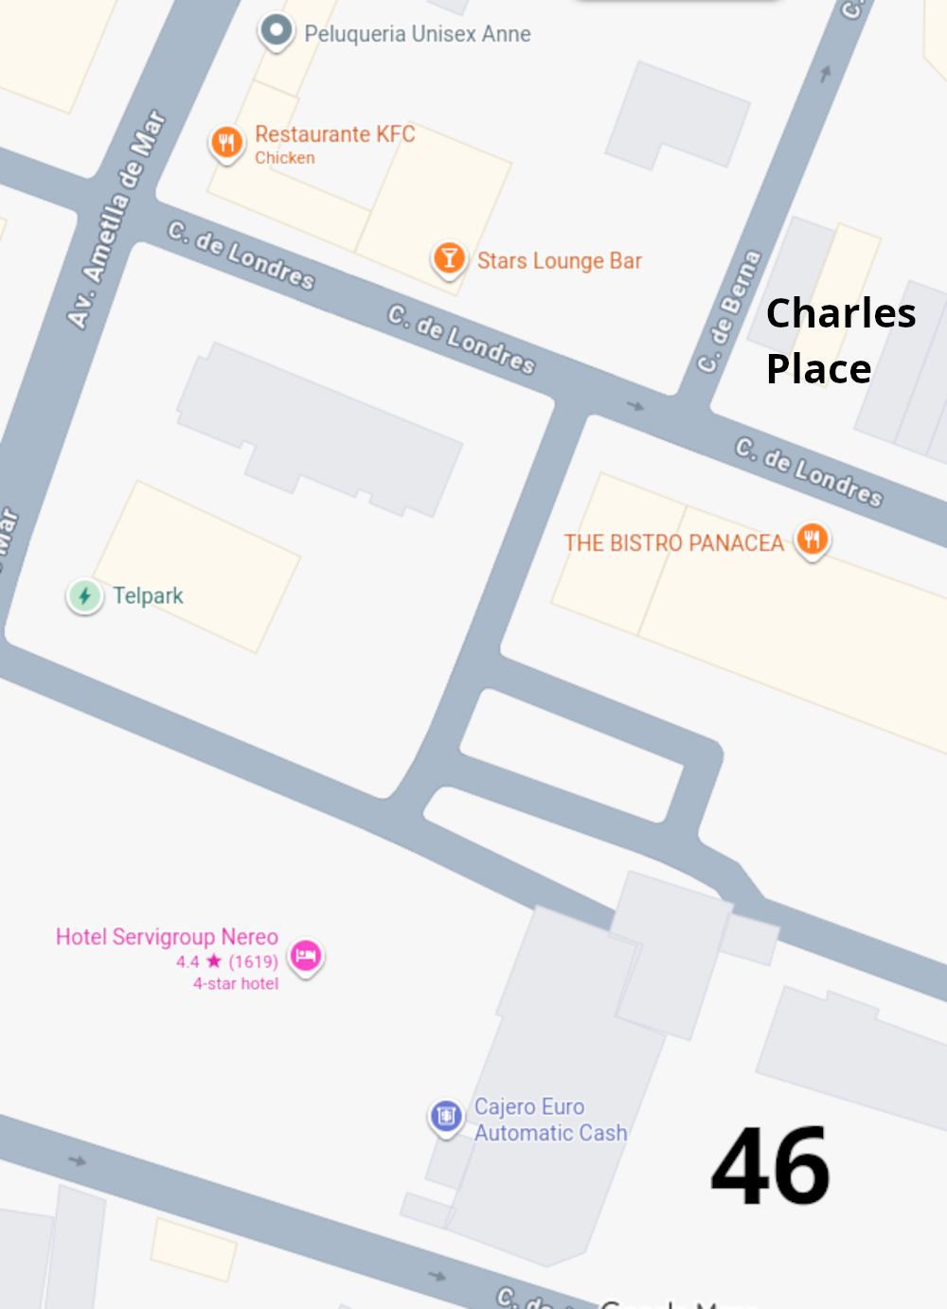
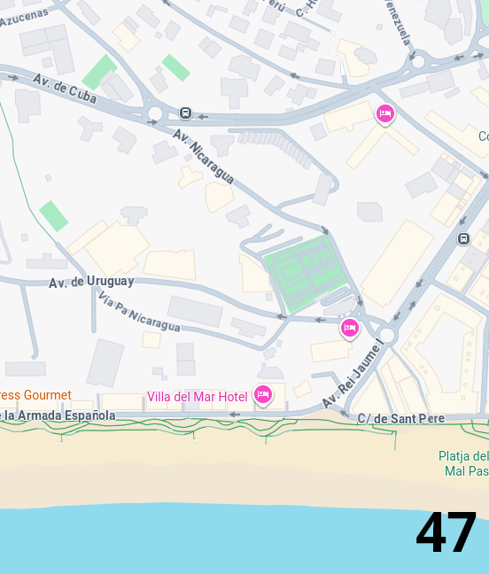
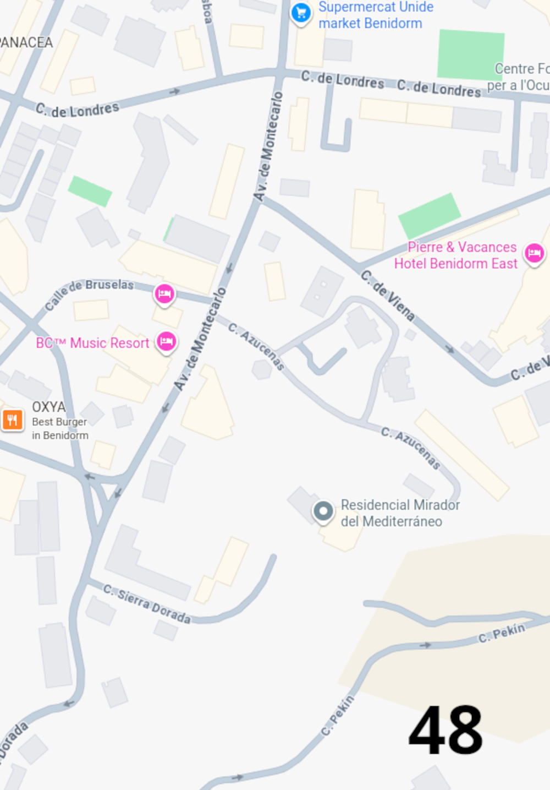
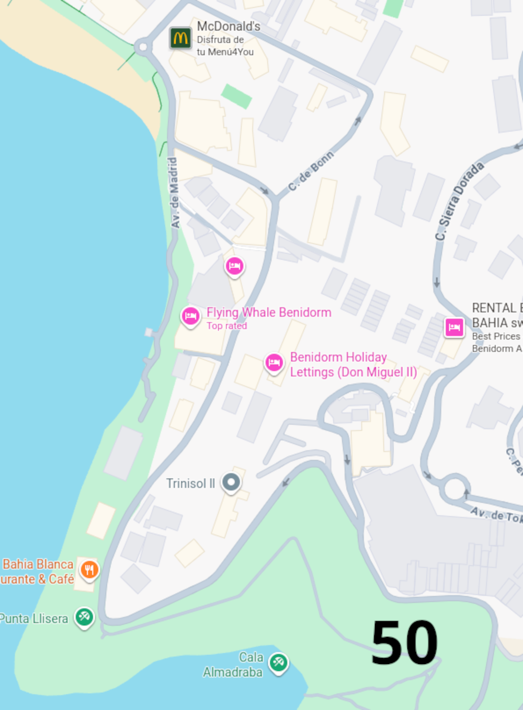
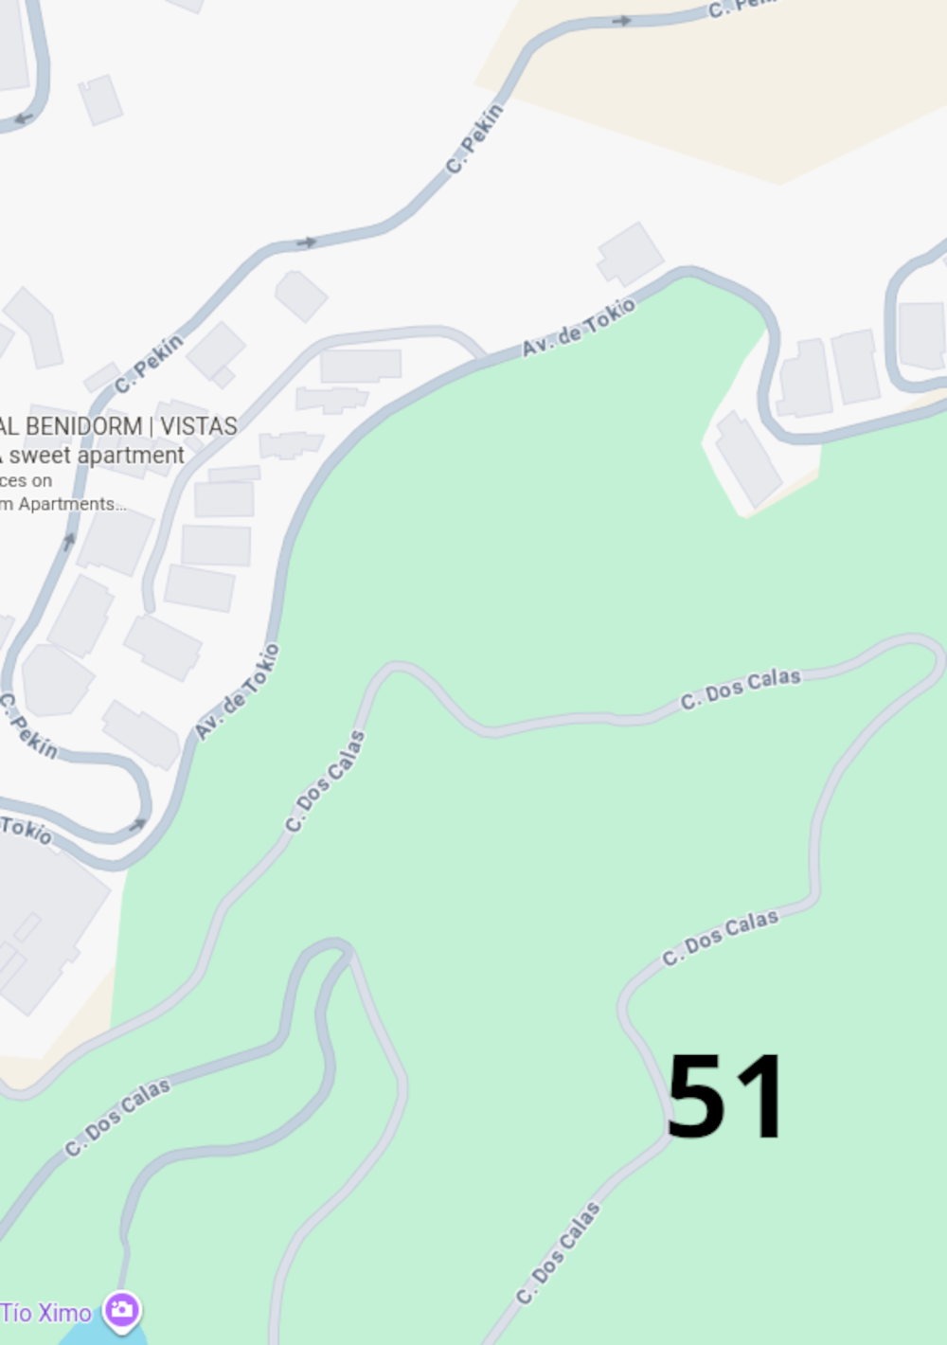
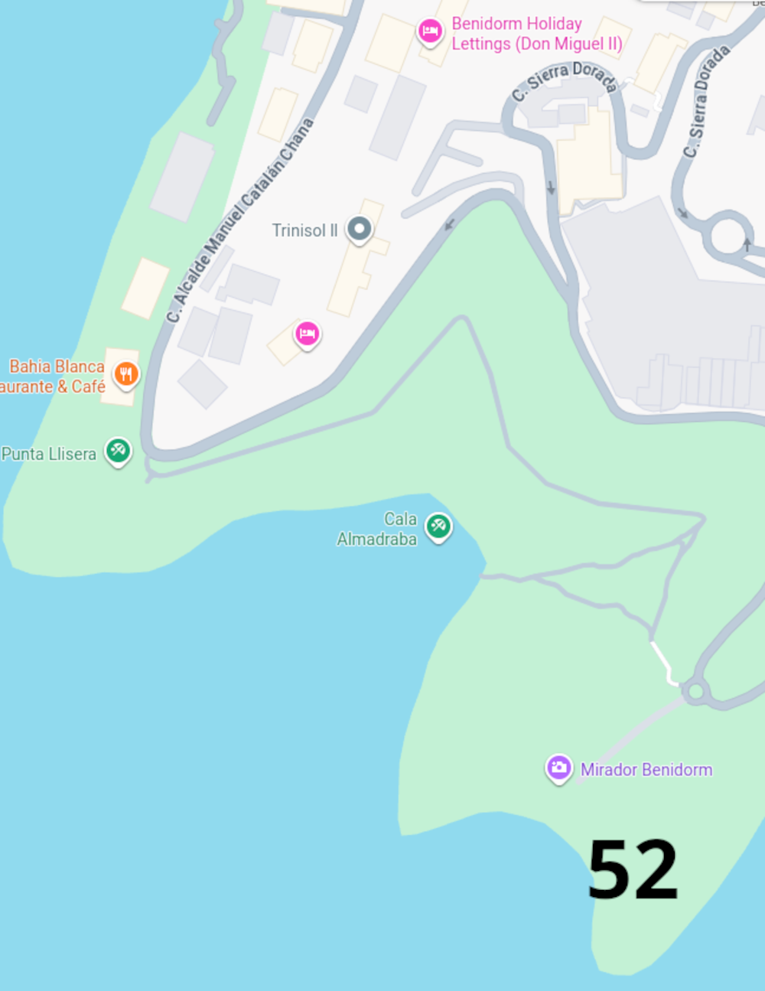
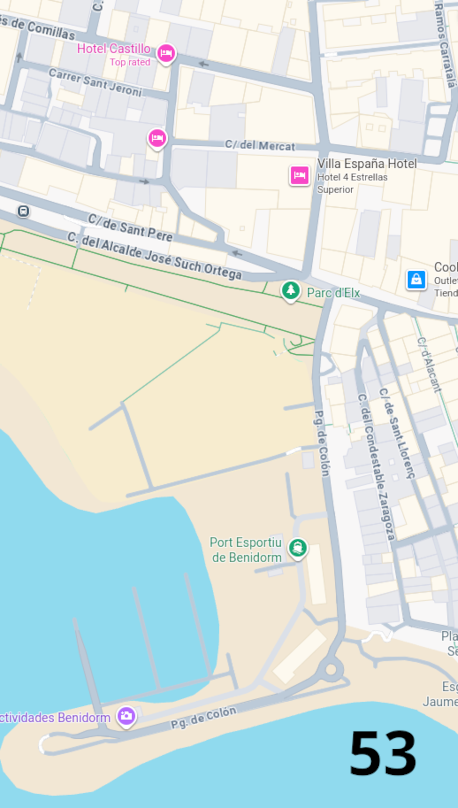
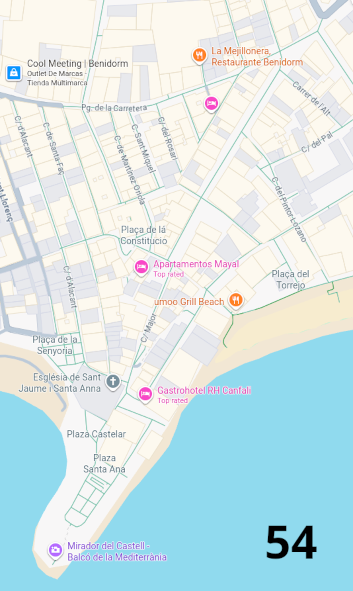

If you are looking for accommodation in Benidorm you can not do better than checking Booking.com.

Some short term flats can be found at
Webhouses.co.uk/Benidorm.php

Our next edition will have advertising from some good Benidorm Hotels. Interested Hotel Managers should get in touch with our advertising department email a12@dr.com or you can phone them at +44 7405 800822

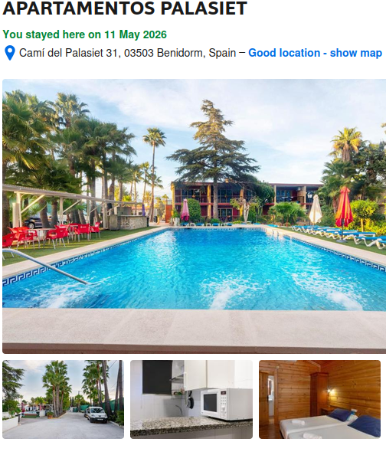
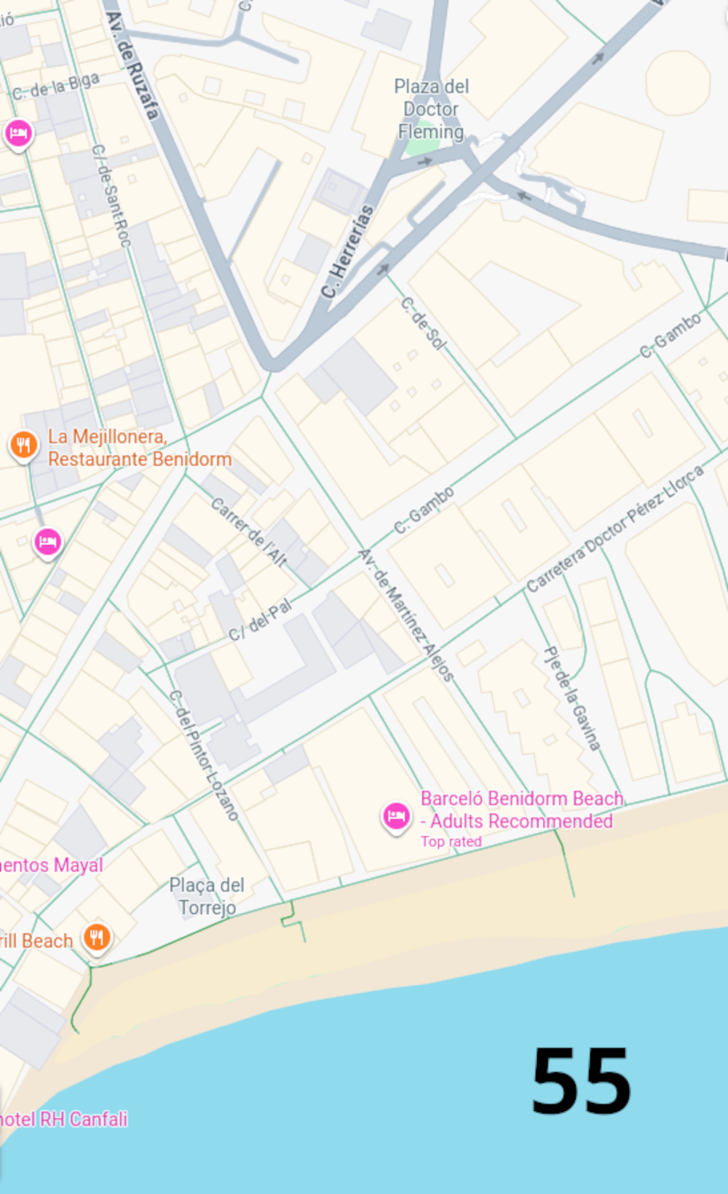
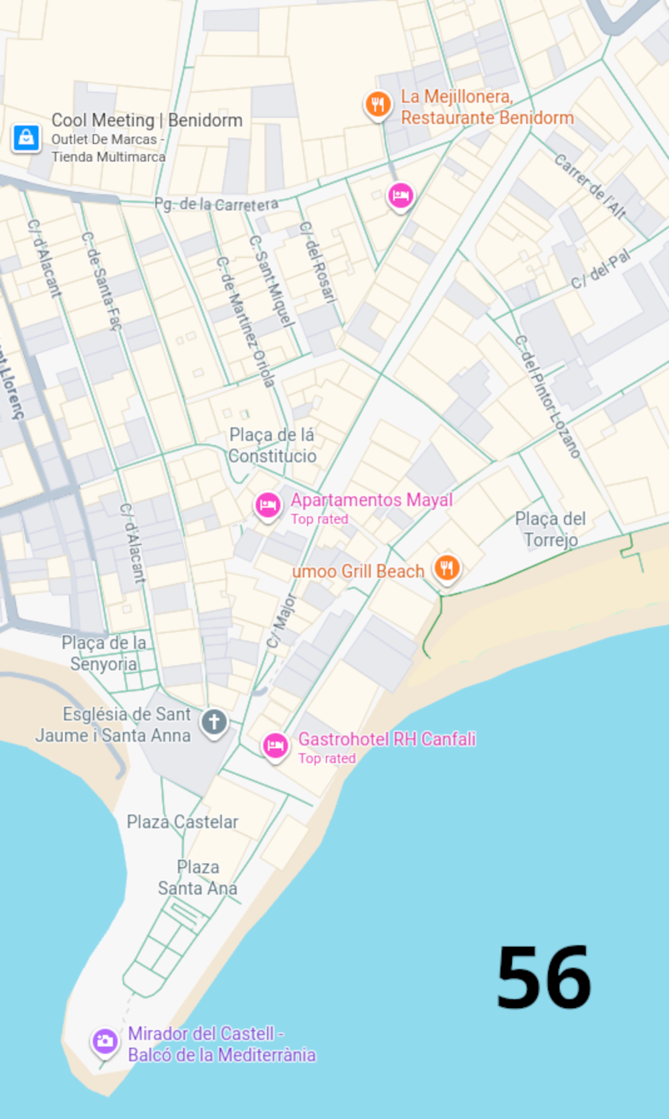
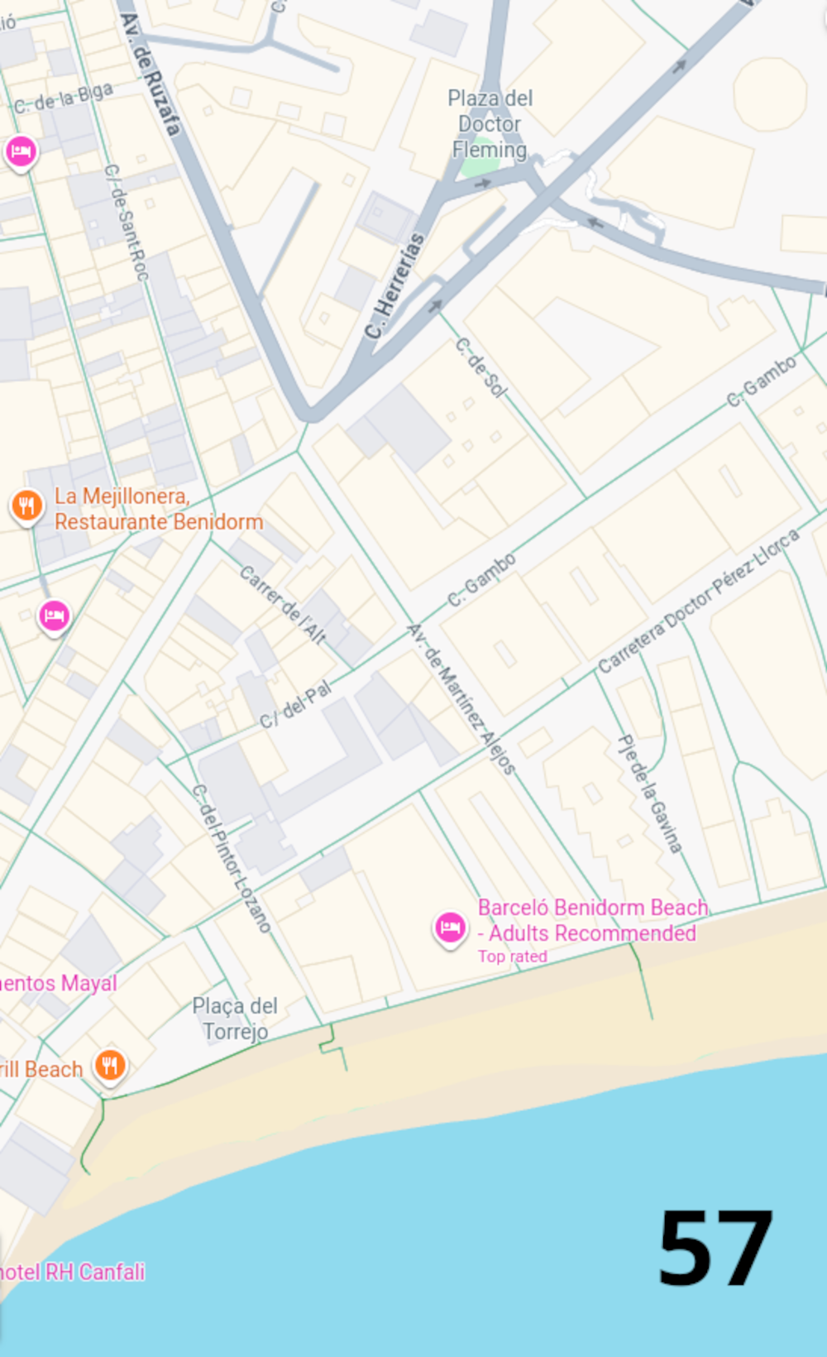
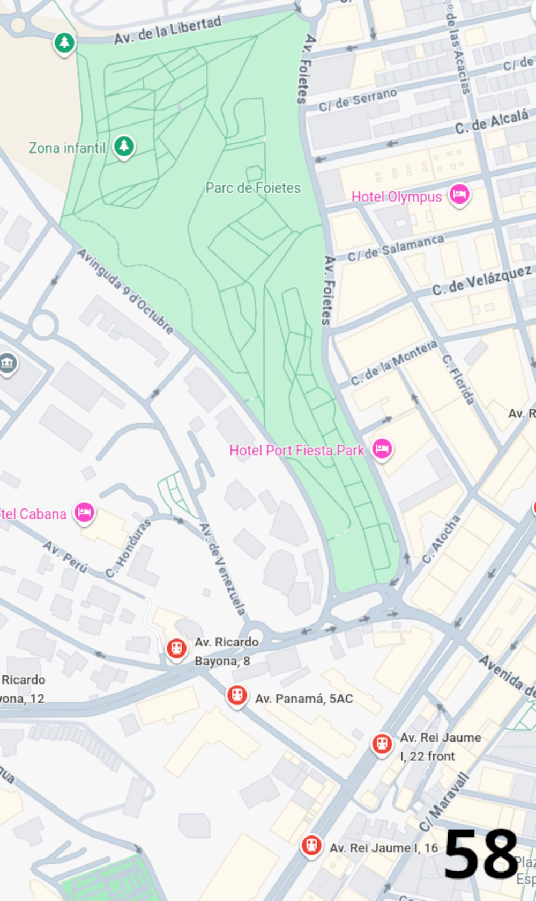
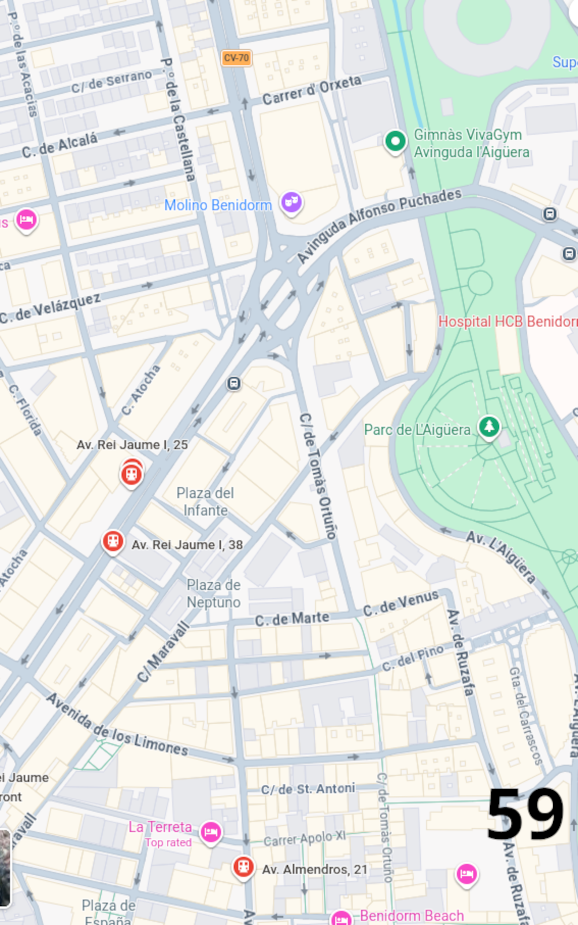
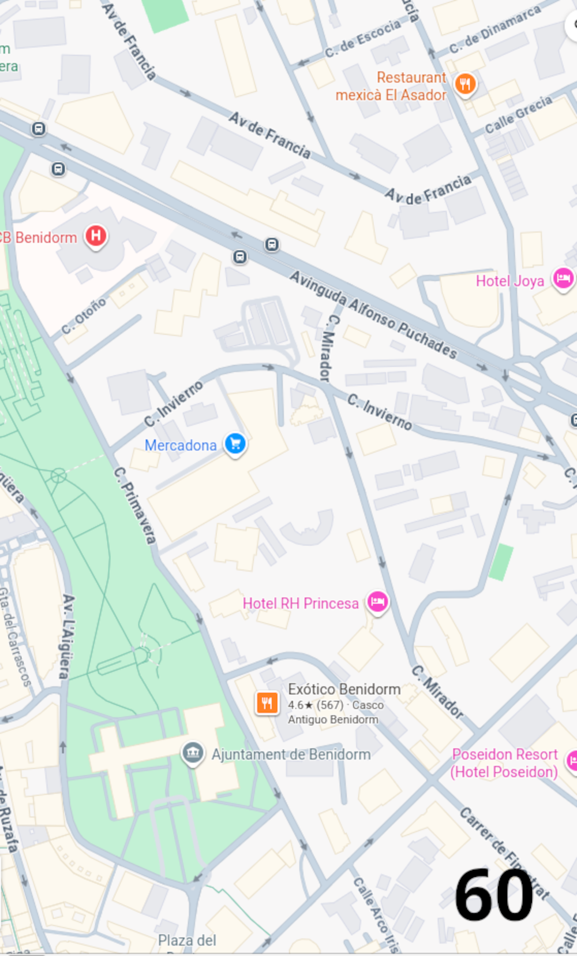
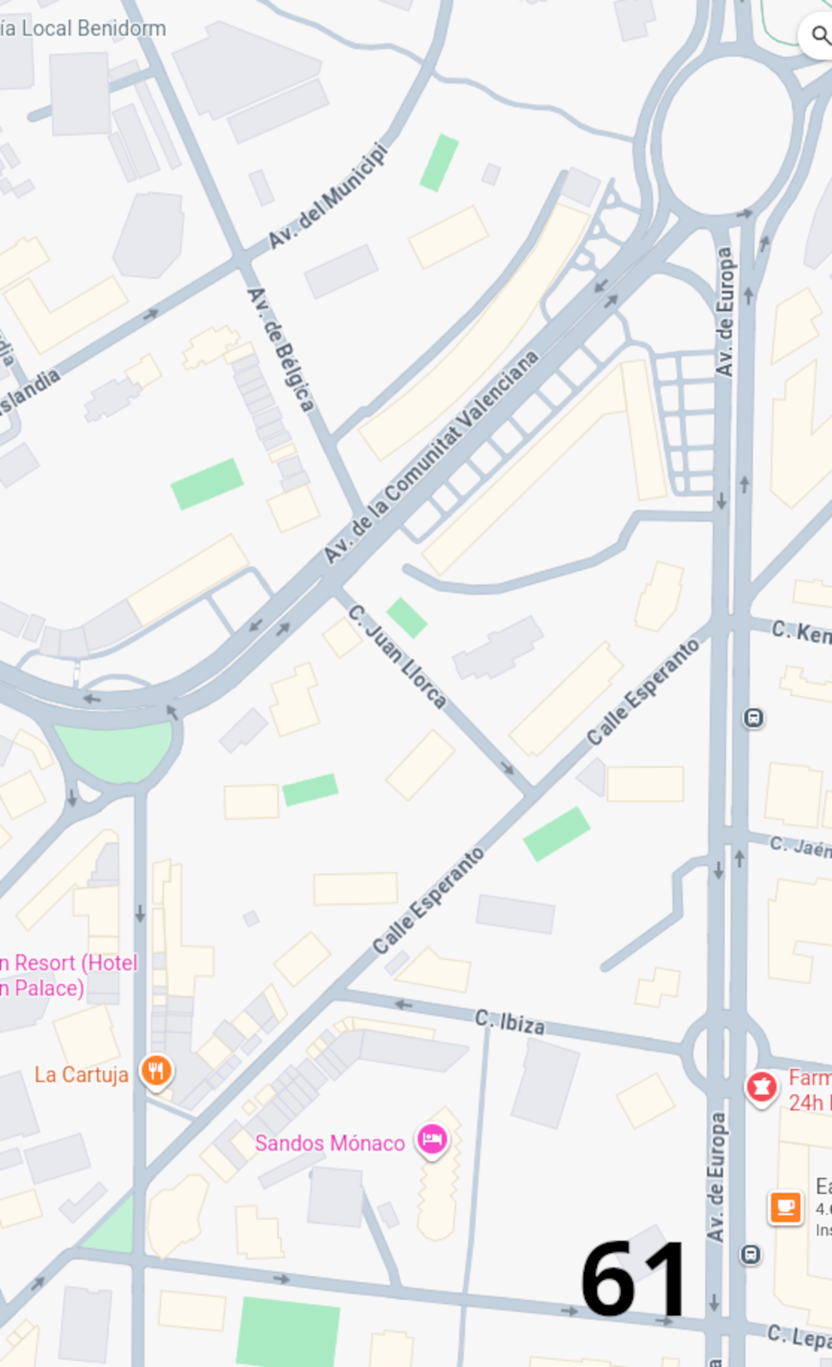
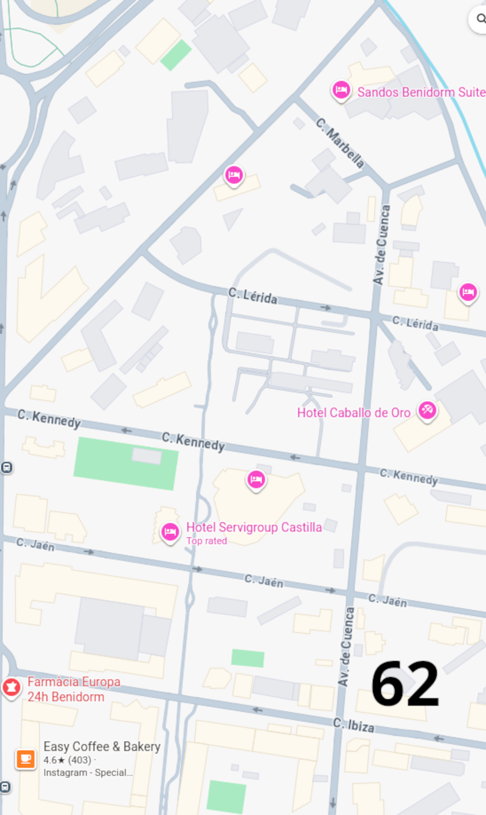

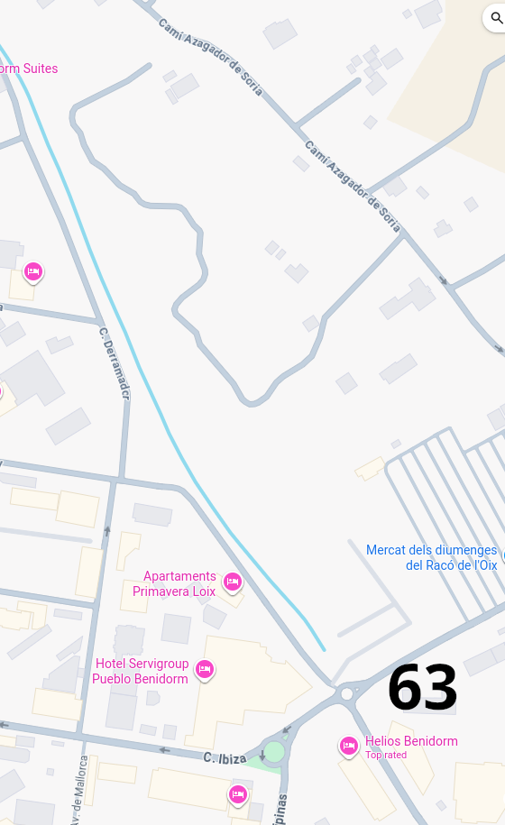
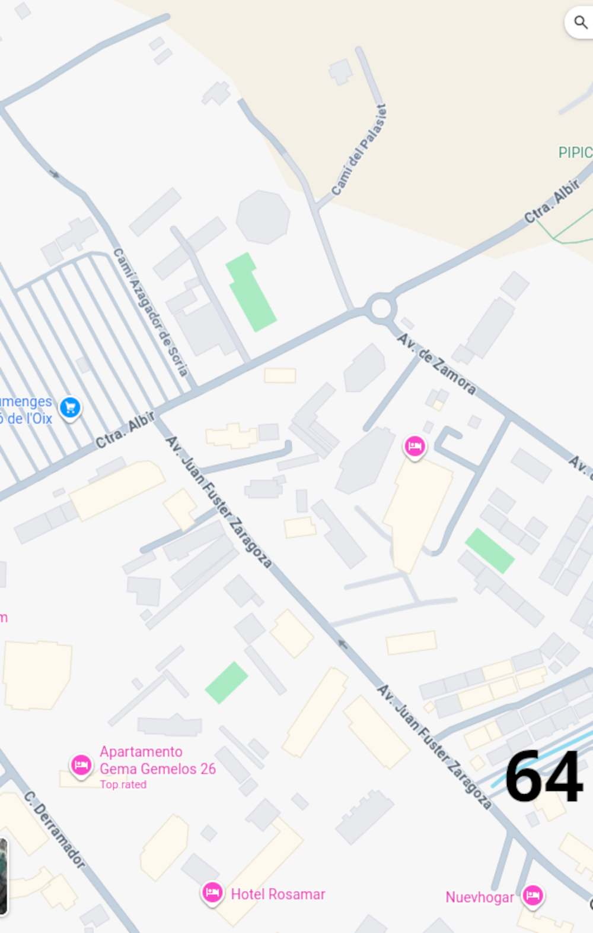
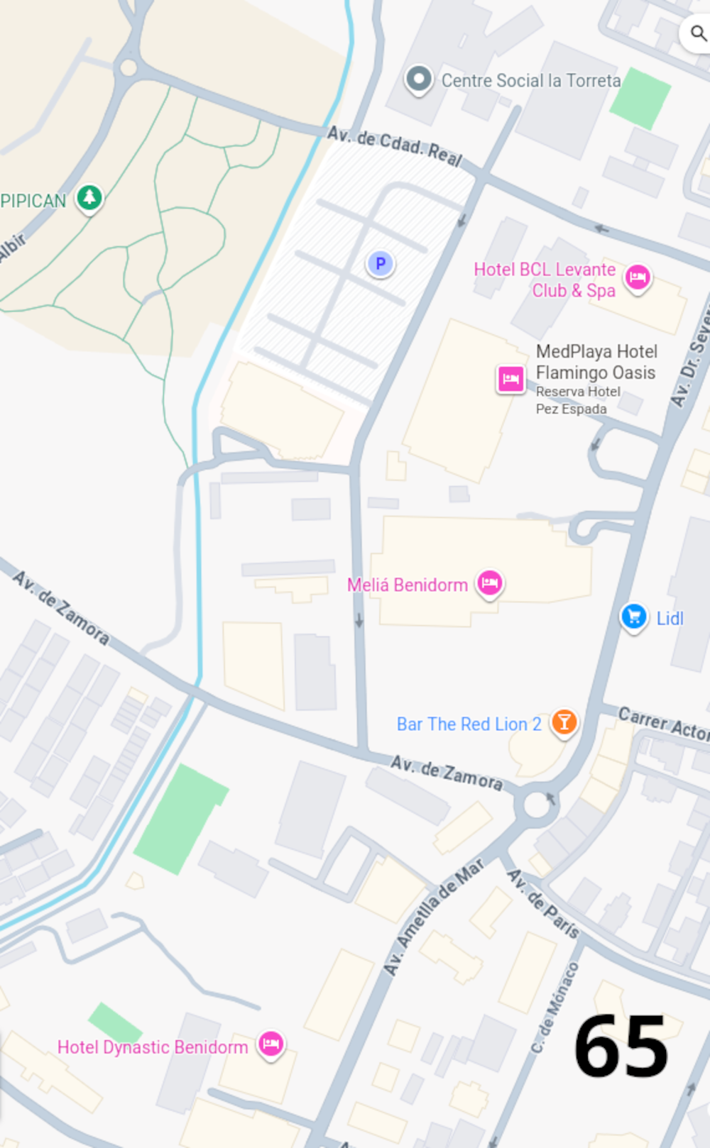

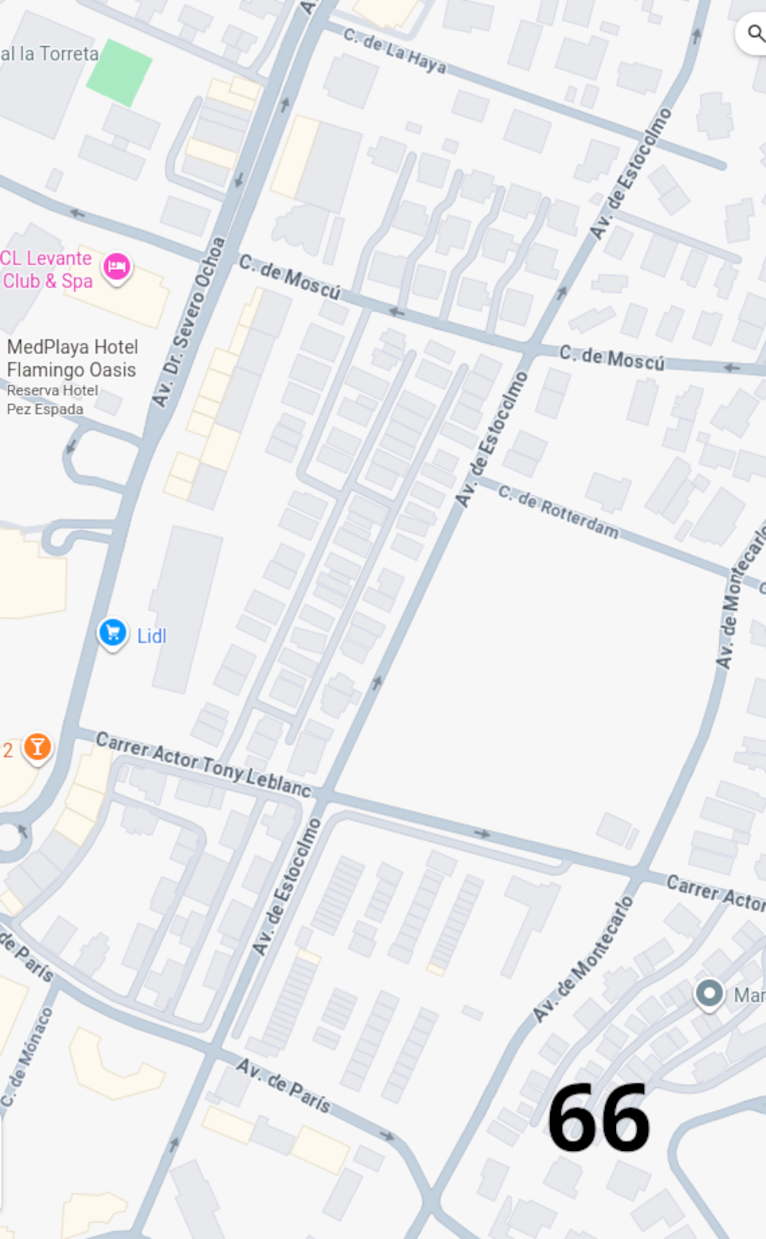
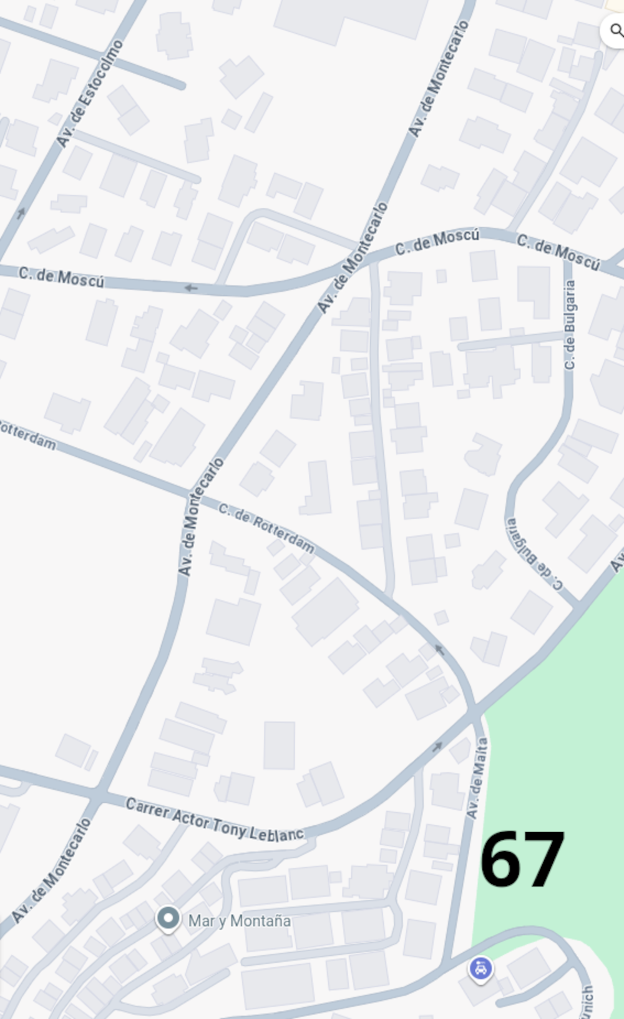
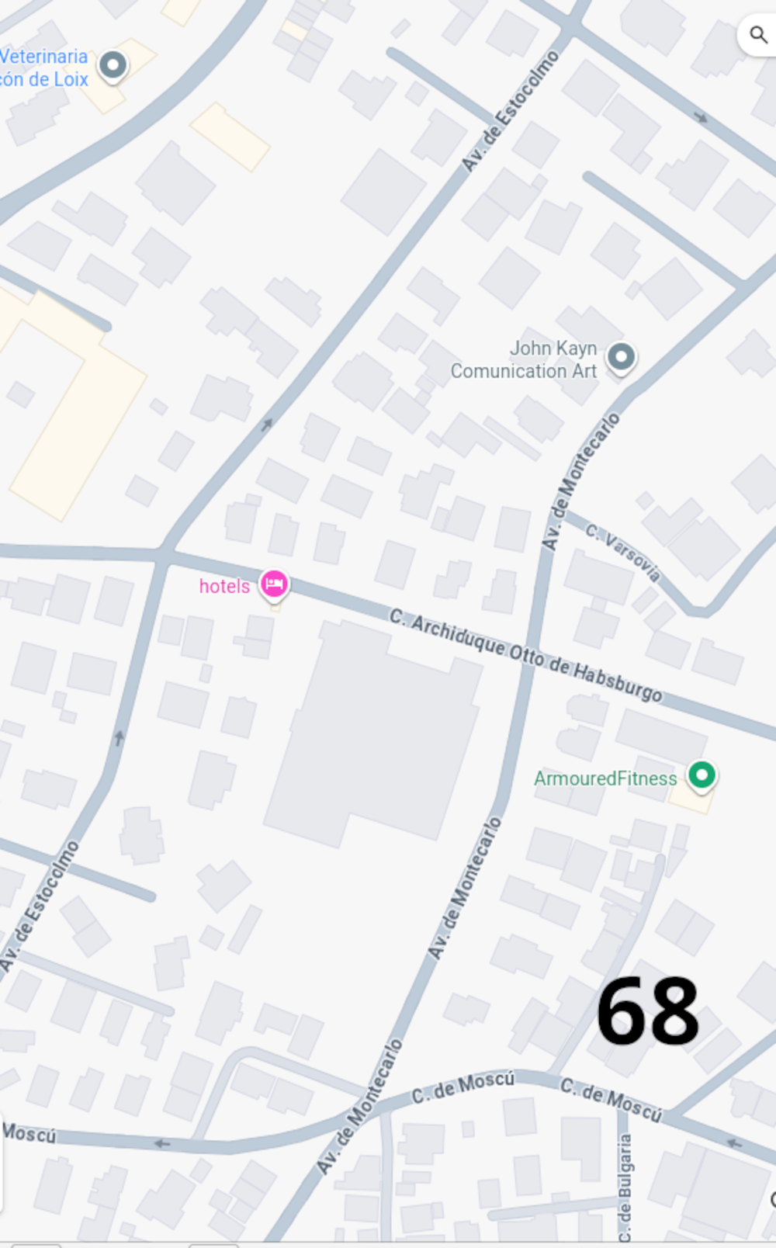
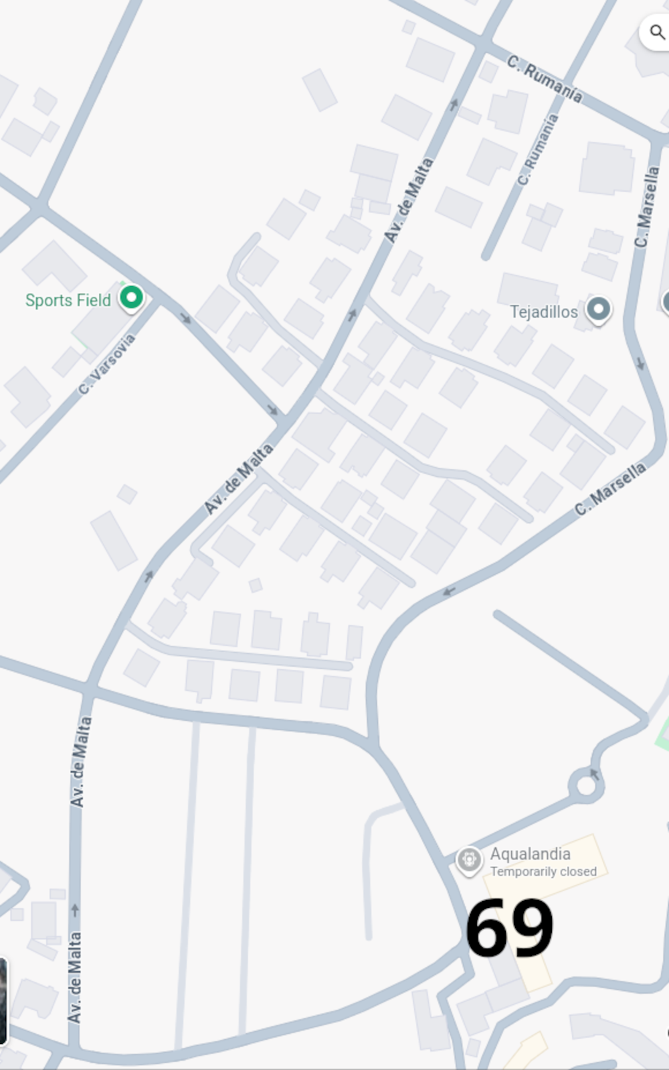
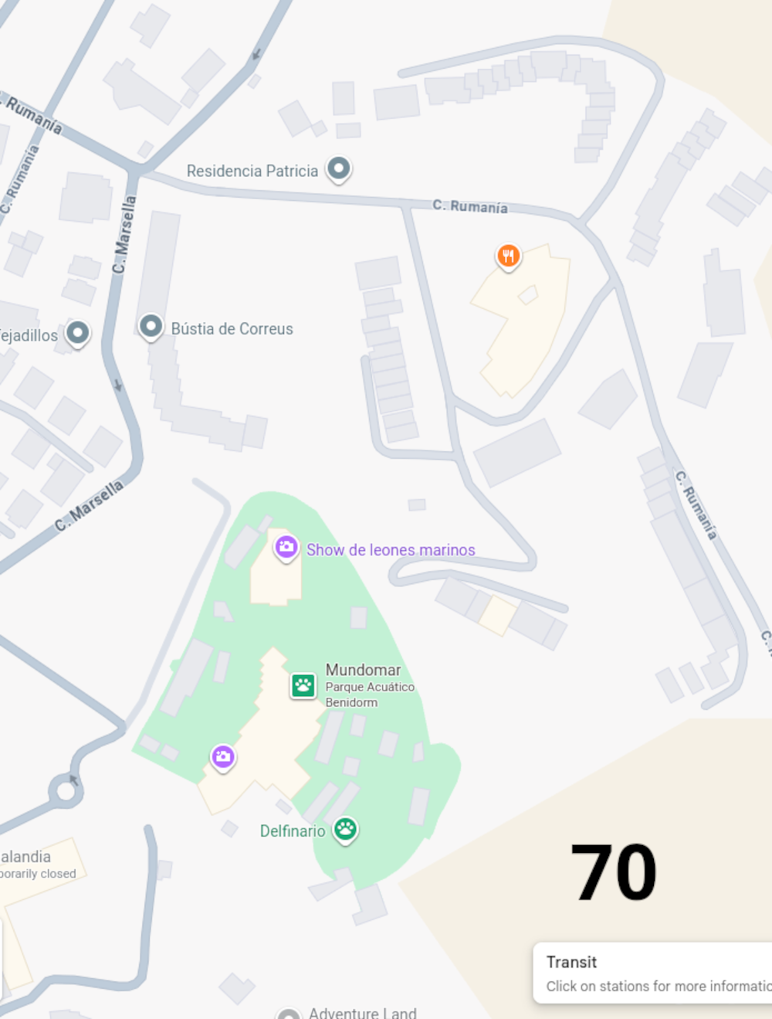
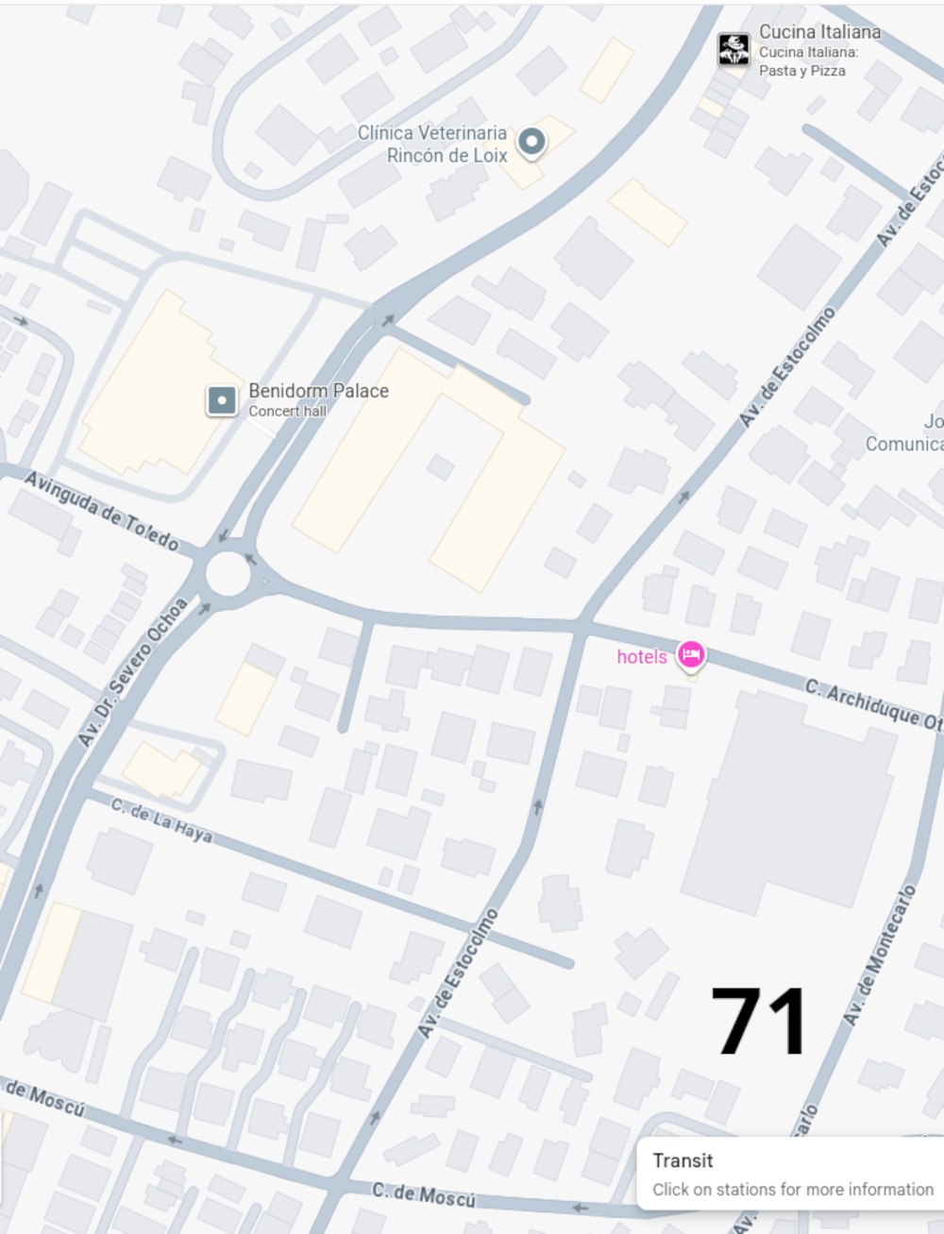
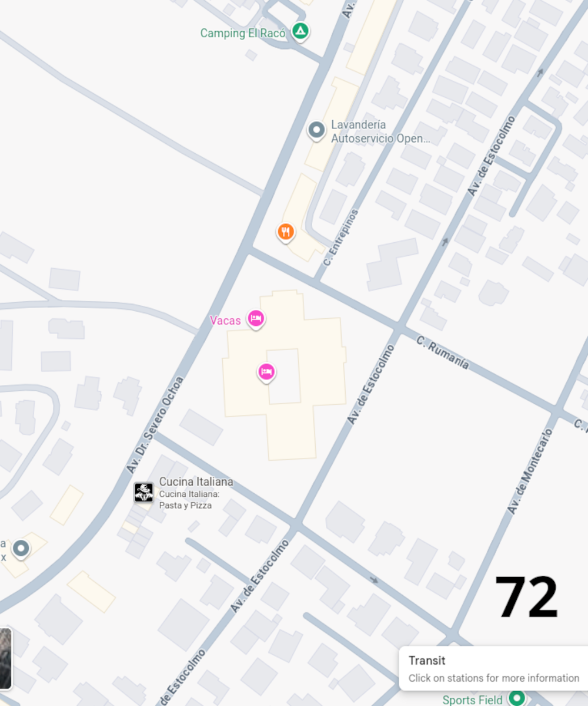
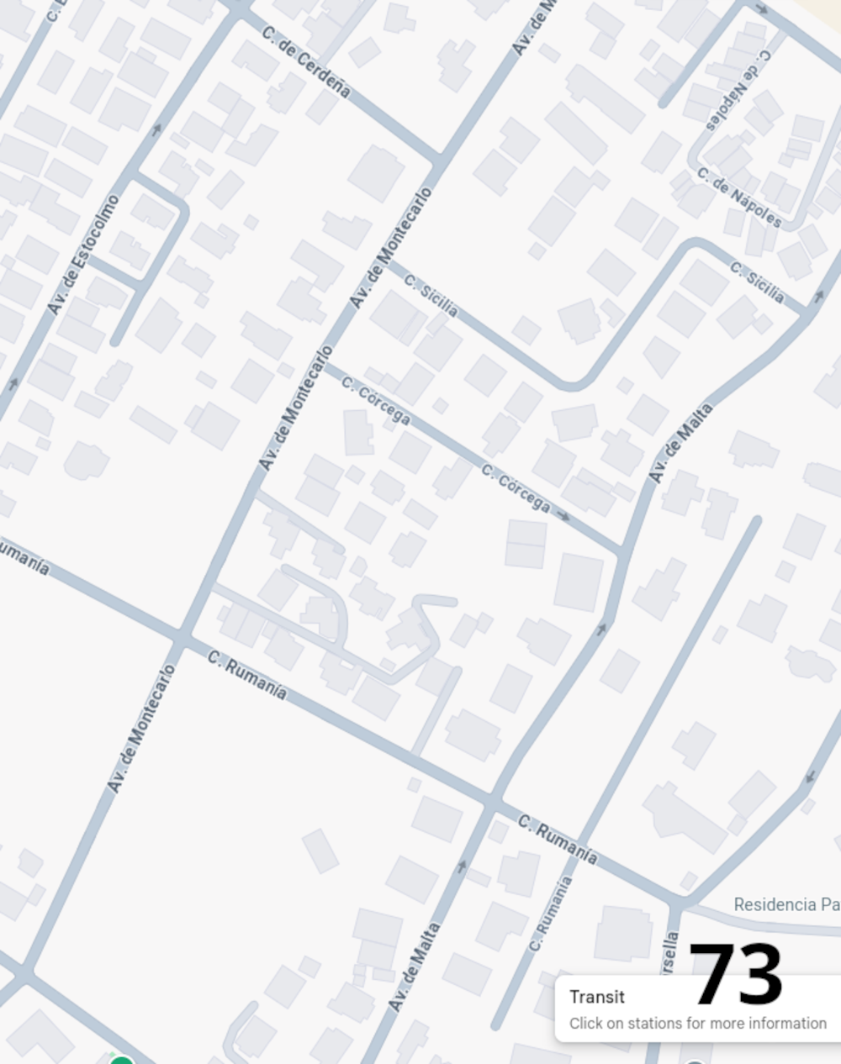

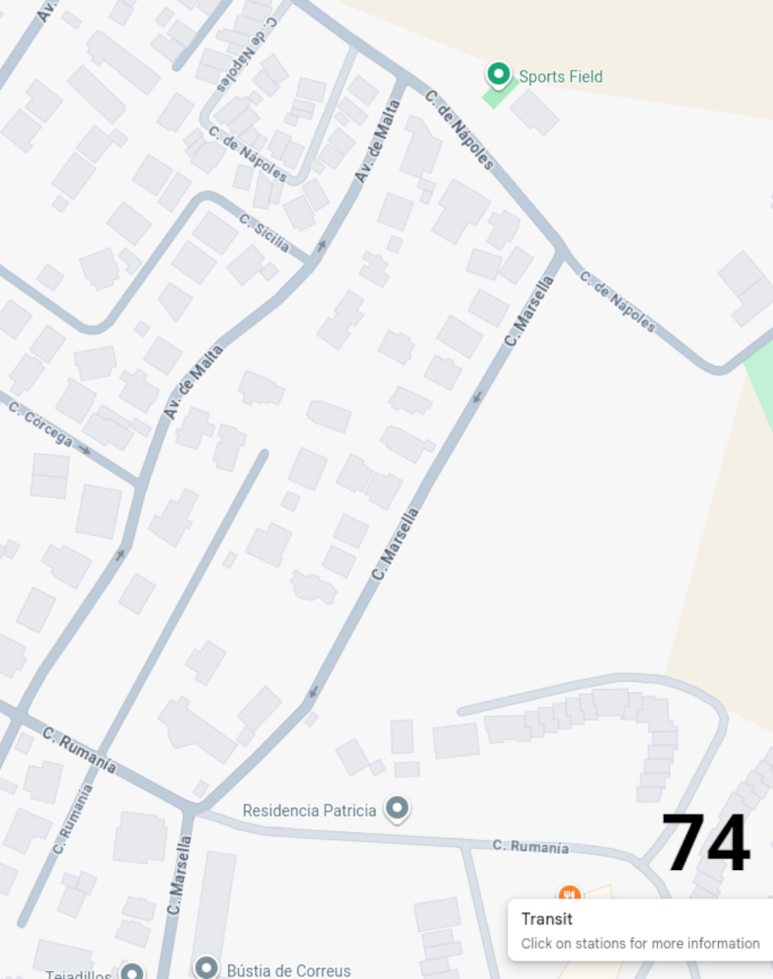
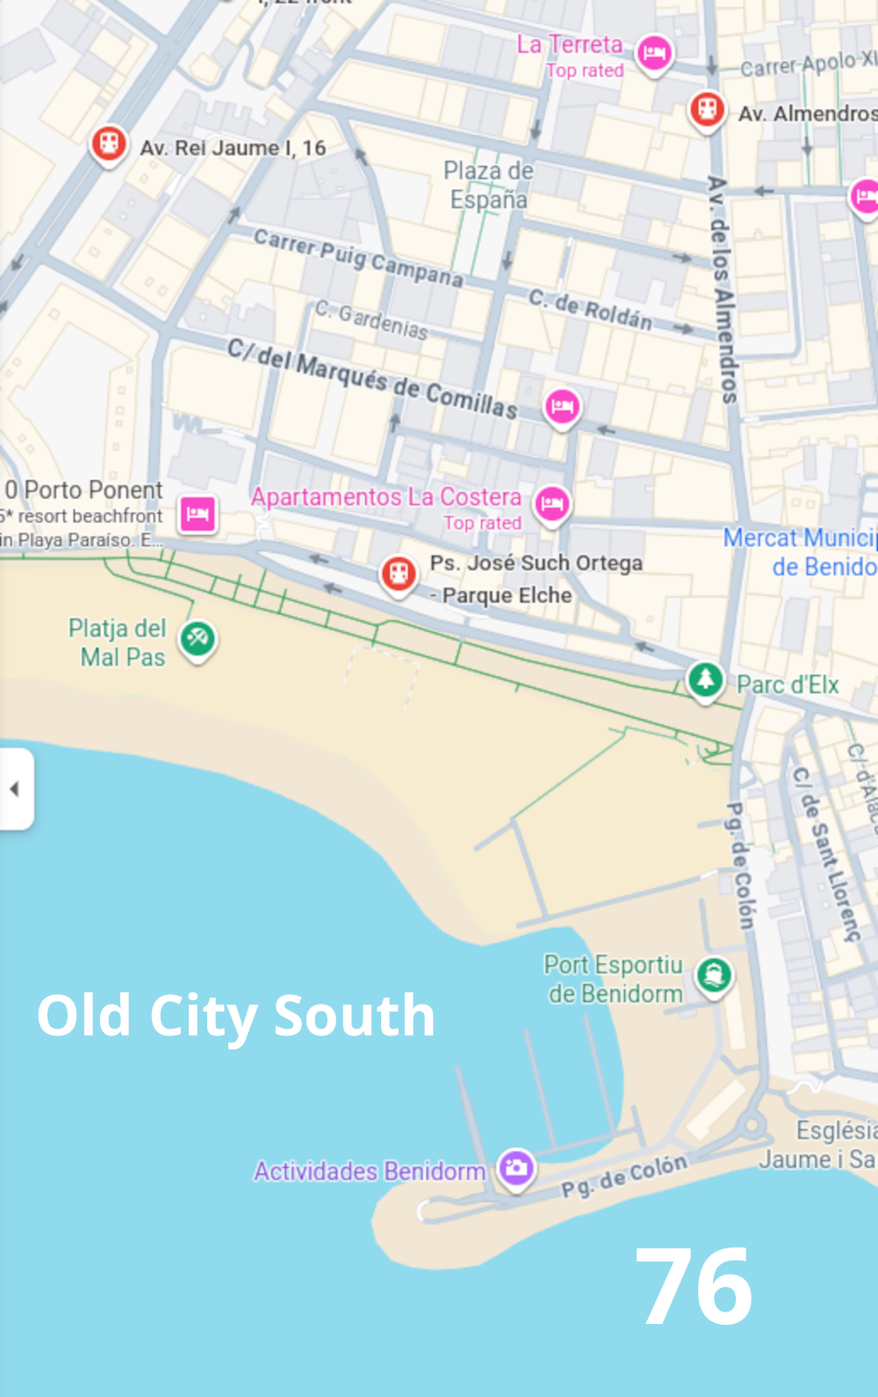
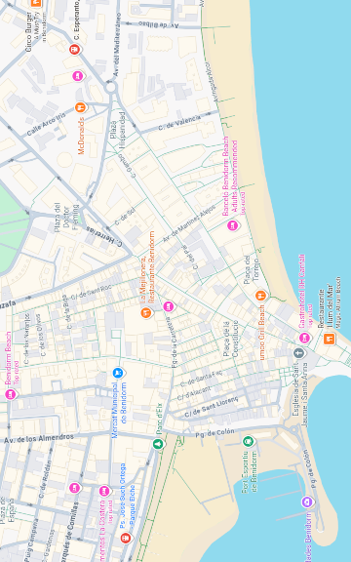
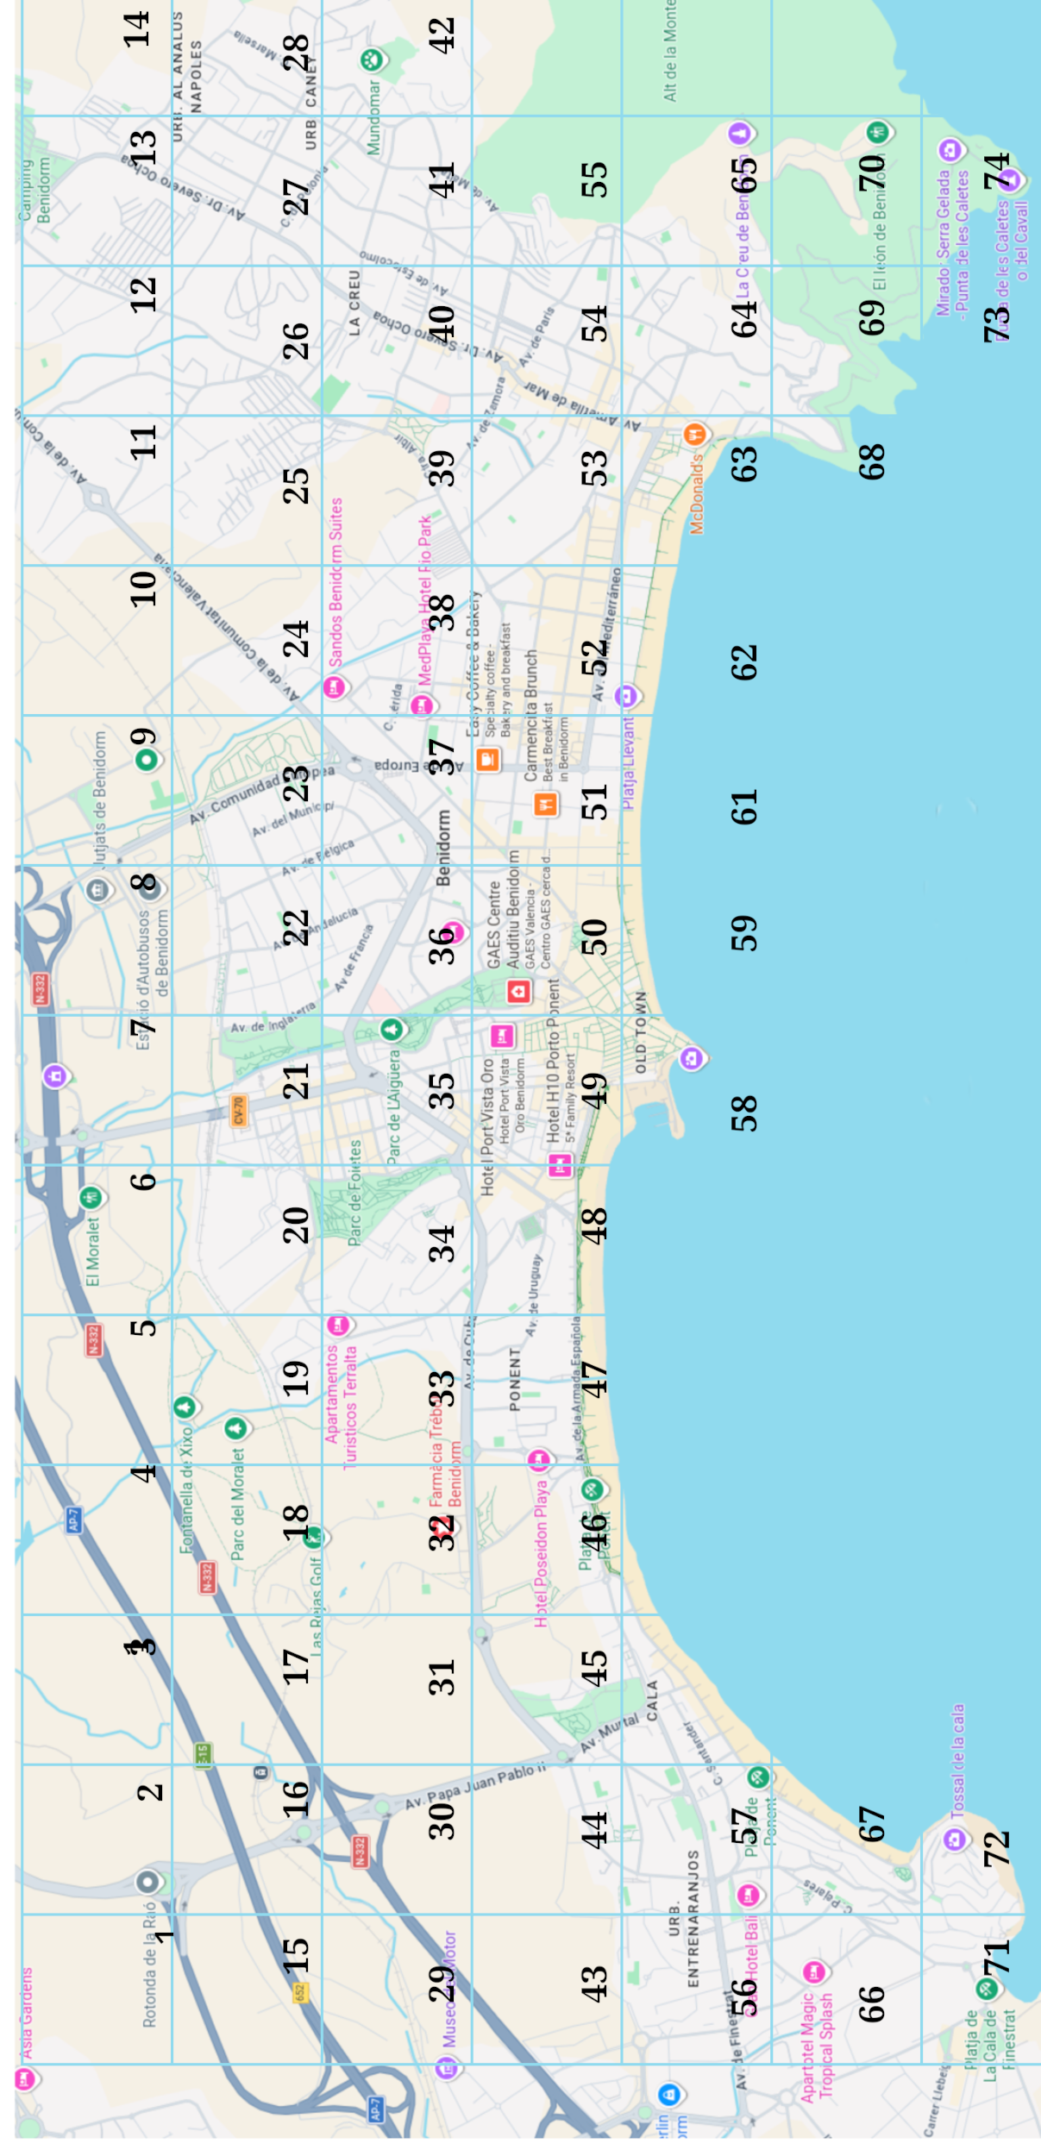

Published by London Publishing Ltd

Copies can be purchased from https://Webhouses.co.uk

Contact us at a12@dr.com with anything you may you would like us to include. Your help in improving this book will be appreciated

